Important Technical Terms
stress Pressures exerted on rocks inside the earth, similar to pressures experienced by divers deep under water.
differential stress When stresses are stronger in one direction than another. For example, a rock deep underground will feel a squeezing pressure in all directions, but the pressure in a vertical direction may be stronger. This is analogous to a deep-sea diver who has a large walrus sitting on him; he is squeezed harder from above (by the walrus) than from the sides (by the water).
strain A change in the shape of a rock body caused by differential stress. For example, a rock may get shorter and thicker or a rock may be bent. In the Earthquakes chapter of the book, when the authors write “strain,” they really mean “elastic strain.”
elastic strain A temporary strain that lasts only as long as the differential stress lasts. That is, when you take away the differential stress; any elastic strain disappears and the rock (or other elastic material) goes back to its original shape. Similarly, if you add a little stress, the strain increases a little; if you take away a little stress, the strain decreases a little and the rock gets closer to its original shape. For example, if you stretch a rubber band, you are applying stress to it and it reacts by straining (becoming longer and thinner). If you increase the stress, it stretches more; if you decrease the stress it shrinks back a little.
brittle strain A permanent strain that remains, even after all stresses are removed. Brittle strain involves breaking and cracking. Fine china easily undergoes brittle strain.
ductile strain A permanent strain that remains, even after all stresses are removed. Ductile strain involves any type of distortion (“morphing”) or bending. Clay easily undergoes ductile strain.
elastic potential energy A form of potential energy that is stored in rocks (or any other elastic materials) when they have undergone elastic strain. Elastic potential energy is released whenever stress is released and the rock (or other elastic material) regains some of its original shape. For example, if you stretch a rubber band and then let go, the rubber band suddenly goes back to its original shape; and enough energy may be released to shoot the rubber band across the room.
rock strength The “strength” of a rock is a measure of how much elastic strain the rock can take before it strains permanently (breaks, slips along a fault, or “morphs” permanently).
The Elastic Rebound Theory for the Cause of Earthquakes

Harry F. Reid formulated the elastic rebound theory as part of his study of the great San Francisco earthquake of April 18, 1906. Harry F. Reid was one member of an eight-person committee, known as the State Earthquake Investigation Commission. This committee did a very thorough job. It carefully mapped almost the entire 780 mile-long San Andreas fault and discovered that a 270 mile-long segment of the fault had ruptured during the 1906 earthquake (see the diagram on p. A–16 of this course packet). Offset roads, fences and other markers indicated that the region west of the fault had moved north relative to the region east of the fault. The maximum amount of offset measured was 21 feet (6.4 meters). The committee also collected eyewitness accounts of the earthquake, gathered seismograph data from seismic stations worldwide, took hundreds of photographs of the ground rupture, and conducted highly accurate surveys of the land near the part of the fault that had ruptured. Their report, first published in 1910, is in the Special Collections section of the CSU Chico library.1 H. F. Reid published a separate paper on his elastic rebound theory in 1911.2
The specific data that led Reid to his elastic rebound theory consisted of land surveys conducted immediately after the 1906 earthquake and older land surveys that had been completed between 1851 and 1906. When Reid compared the post-earthquake surveys with the older surveys, he detected an interesting pattern. The diagram below shows, in idealized form, the results of these surveys.
As you might expect, these data were, at first, rather puzzling. Why should an originally straight survey line become broken and, worse, curved? Reid suspected that the part of California on the west side of the San Andreas fault was moving, very steadily and gradually (a couple of inches a year), northward relative to the part of

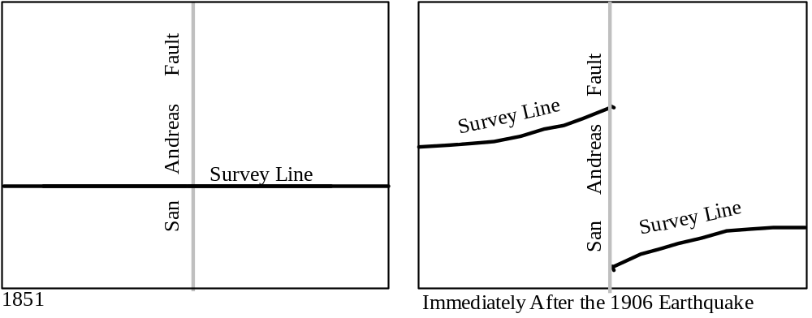

1Reid, Harry F., 1908-1910, The mechanics of the earthquake: Volume 2 of The California earthquake of April 18, 1906: Report of the state earthquake investigation commission: Carnegie institution of Washington Publication no. 87.
2Reid, Harry F., 1911, The elastic-rebound theory of earthquakes: University of California Publications in Geological Sciences, v. 6, no. 19, p. 413-444: Berkeley, CA, University of California Press.

California on the east side of the San Andreas fault.3 He also suspected that these two parts of California did not slide smoothly past each other. He suspected, rather, that they stuck together along the San Andreas fault for decades at a time.
Now this sticking would not stop the two regions from moving relative to each other, inch by inch year after year. It would just mean that the rocks near the fault would get stretched, compressed, and/or bent as they stubbornly clung to each other despite being pulled in different directions by the two slabs of crust they were attached to (see the diagram on the next page).
Now this stretching, compression and bending (called strain) would be elastic, meaning that the rocks would only remain in their distorted condition as long as they were being pulled, squeezed, or otherwise stressed. And the more stress the rocks were subjected to, the more elastic strain they would accumulate. It takes energy to hold the rocks in this strained position. Thus, as the elastic strain accumulated in the rocks, the elastic potential strain energy would too.
Now, as you may have guessed, there is a limit to how much you can stretch, squeeze or bend a rock before it just can't take any more. Reid realized that, when this point is reached, all of a sudden, the two sides of the fault would “let go” of each other and slide violently past each other. The stress on the rocks would be instantly relieved, the rocks would unbend as the elastic strain was suddenly removed, and tremendous amounts of elastic strain energy would be released, causing the ground to vibrate vigorously and send earthquake waves out in all directions.
To test this theory, Reid--like all good scientists--constructed a model (he made his out of jello) that behaved the way he thought California was behaving near the San Andreas fault. He then tested his model to see if it could produce the survey results that he and the rest of the commission had gotten. Sure enough, it worked! (A–5 and A–6)
The survey lines in the model behaved just like the actual survey lines on the ground did. Any originally straight survey line that had been drawn immediately after the previous major earthquake (there were none of these--it had been too long ago) would have gradually become bent over the years and then, after the earthquake, become broken and offset but--once again--straight. However, any originally straight survey line that was drawn after a significant amount of strain had already accumulated in the rocks near the fault (there were lots of these lines) would have been drawn on rocks that were already distorted; in essence, the surveyors would have drawn a straight line on a crooked grid. Over the years, as more strain accumulated, the originally straight more recent survey line would also become curved. After the earthquake, as the now very crooked grid would straighten out, the more recent survey line would break and become curved in the direction opposite the way it had curved before the earthquake. In other words, any more recent survey lines would become broken, offset and curved just as the 1851 survey lines did (Compare the diagrams on p. A–5 and A–6 to the diagram on p. A–2). Reid's elastic rebound theory worked!
And it still does. Harry Reid's theory has withstood the test of time. It has been confirmed over and over again. It is highly compatible with plate tectonics and is the basis for long-term prediction of earthquakes.

3He had no inkling of the theory of plate tectonics. So he had no idea that the western part of California was just part of a much bigger plate that included most of the Pacific Ocean. And he had no idea that the eastern part of California was just part of a much bigger plate that included all the rest of North America.
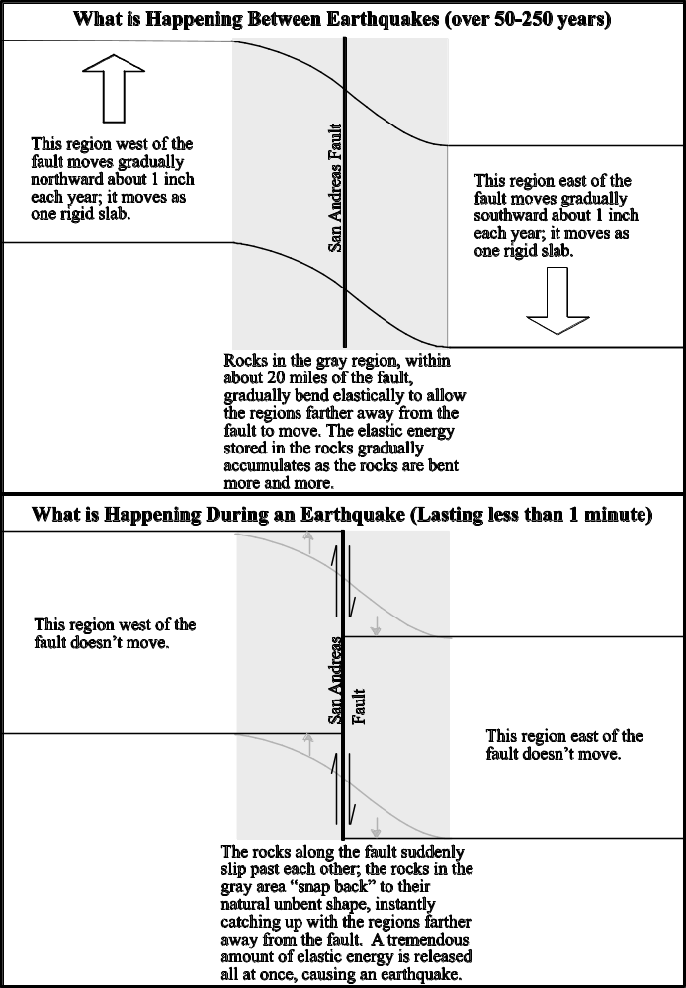
Harry F. Reid's Model and How it Produced the Observed Changes in the 1851 Survey Lines

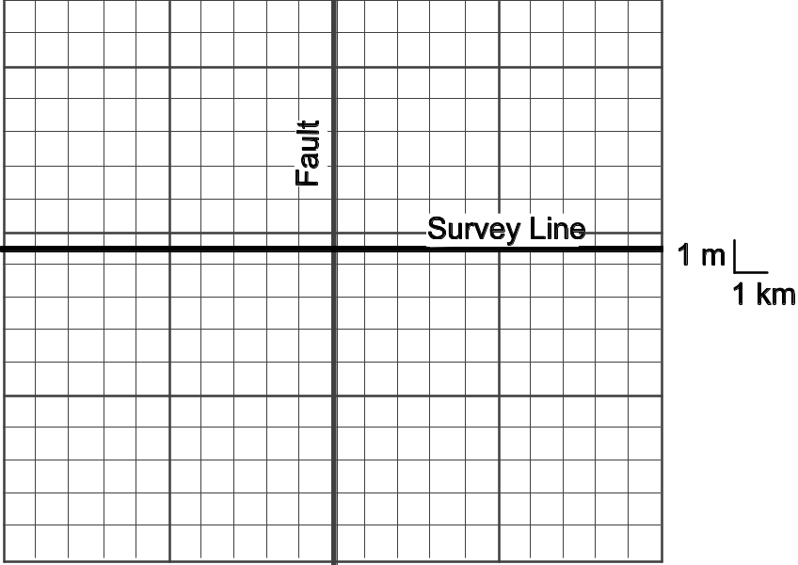
Immediately after a major earthquake

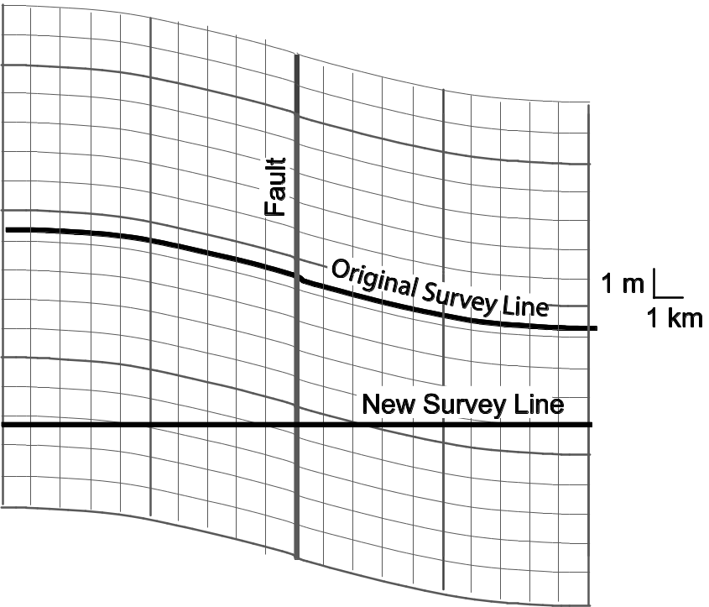
About 50 years later (Recurrence interval on this fault is 100 years.)
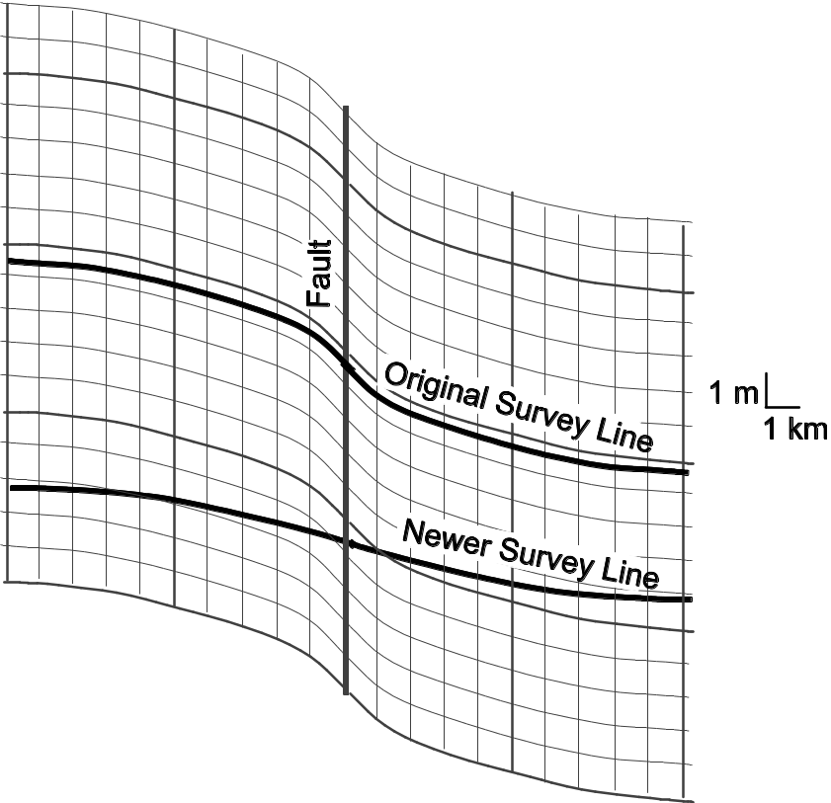
After another 50 years (Just before the next major earthquake)
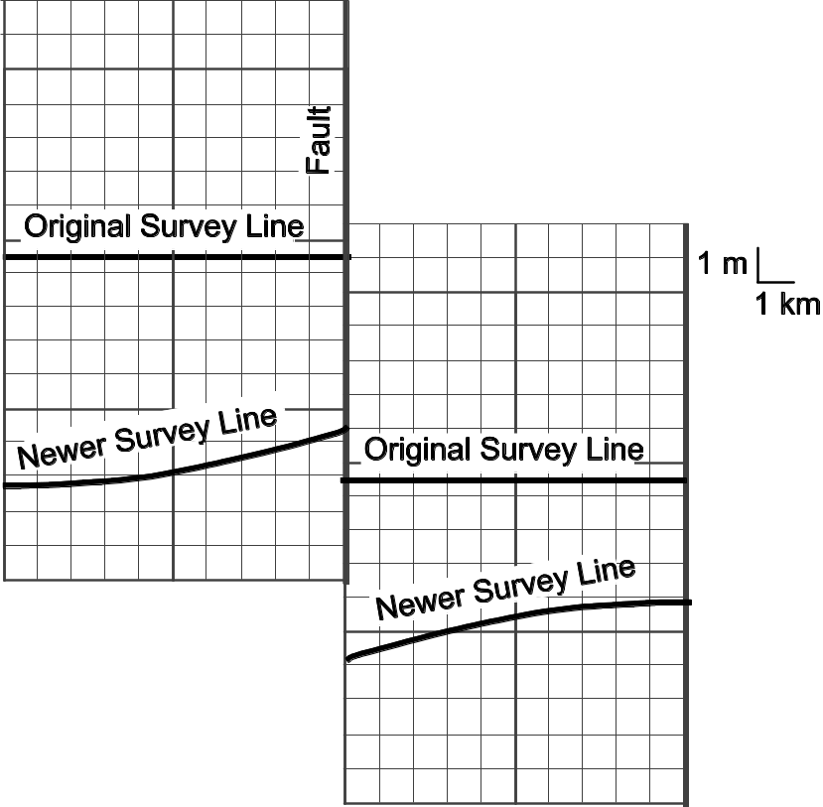
A few years later (just after the major earthquake happens)

Thermal Expansion
If you have completed the lab activity on Density, Buoyancy and Convection, you experienced first-hand a phenomenon called thermal expansion:
• As the temperature of a substance increases, its volume also increases (it expands).
The converse is also true:
• As the temperature of a substance decreases, its volume also decreases (it contracts).
You may have been wondering how this could happen. Do the individual molecules expand and contract? Careful scientific investigations reveal that they do not. Molecules do not change size.
So what could be happening to cause substances to expand and contract? Well, in any given substance, there is lots of empty space between the molecules. Let's look at a small beaker of water for example. If we could somehow magnify the beaker, we would see what looks like billions of bouncing Mickey Mouse heads (water molecules) in a gigantic glass room with no roof. There is a fair amount of space between the Mickey Mouse heads. The warmer the Mickey Mouse heads are, the more energy they have. The more energy they have, the faster they move and the harder they bounce off of each other. So, if they heat up, they bounce harder and therefore spread out a bit, reaching a bit higher up toward the top of the glass room and leaving a bit more empty space between them--the group of Mickey Mouse heads expands without changing the sizes of the Mickey Mouse heads themselves.
At the molecular level that is what a beaker of water looks like and that is how it expands. But the analogy isn't perfect; it does break down. In a room full of bouncing Mickey Mouse heads, what occupies the space between the Mickey Mouse heads? Air, right? In a beaker of water, there may be a small amount of air dissolved in the water, but even if we boil the water for a long time, driving all the dissolved air out, there is still space between the water molecules. What is in that empty space? Air? That can't be--we've boiled the water and driven all of the air molecules out. So what's in that empty space? NOTHING! Nothing at all. It's pure empty space.
So substances expand when heated simply because the individual molecules move faster, bounce against each other harder, and therefore spread out more, leaving more empty space (not air!) between the molecules than before.

Density
Density is “a measure of the compactness of matter, of how much mass is squeezed into a given amount of space; it is the amount of matter per unit volume.” (Hewitt, P.G., 1985, Conceptual Physics, 5th edition, p. 170). Here is a mathematical way to express what density is:

Density =
Population density is a good analogy for density of matter. A densely populated city, such as San Francisco, is full of high-rise apartments. A lot of people are crowded into every city block. A less densely populated city, such as Chico, is full of single-family homes with good-sized yards. Fewer people are crowded into each city block. Here are the densities of a number of substances:

Substance | Density (in g/cm3)
Ice at -100°C | 0.9308
Ice at -50°C | 0.9237
Ice at -25°C | 0.9203
Ice at 0°C | 0.9168
Water at 0°C | 0.9998
Water at 4°C | 1.0000
Water at 25°C | 0.99705
Water at 50°C | 0.98804
Water at 100°C | 0.9584
Continental crust | 2.7
Oceanic crust | 3.0
Mantle lithosphere | 3.4
Mantle Asthenosphere | 3.3

Changes in Density with Temperature
As the temperature of a substances changes (and nothing else changes), the density changes systematically. You can see how this works in the table above. Compare the densities of water at different temperatures. Also compare the densities of ice at different temperatures.

Buoyancy
Buoyancy is “the apparent loss of weight of objects submerged in a fluid” (Hewitt, P.G., 1985, Conceptual Physics, 5th edition, p. 184). If you've ever tried to lift a boulder under water, you know that it seems to weigh much less than it does in air. Boulders are more buoyant in water than in air. Yet boulders will sink in water. Fish are even more buoyant in water than boulders are; they are so buoyant that they are essentially weightless in water. Fish neither sink nor float. Logs (as long as they're not water-logged) are even more buoyant than fish are. In fact, logs seem to have negative weight in water--they “fall” up (float) if you let them go.
Just as different solid objects have different buoyancies in a fluid, different fluids also have different buoyancies relative to other fluids. For example, oil always floats to the top of a bottle of vinegar-and-oil dressing; oil is more buoyant than vinegar is. What determines whether a substance sinks or floats in a given fluid? Density! Here are three simple rules:
1. If a substance is denser than the fluid in which it is immersed, it will sink.
2. If a substance is less dense than the fluid in which it is immersed, it will float.
3. If the density of a substance equals the density of the fluid in which it is immersed, it will neither sink nor float.

Convection
Convection happens in any fluid that is hotter on the bottom than it is on the top. This is also true of solids that can flow (ever so slowly) like fluids. Due to thermal expansion and contraction and the resulting changes in density and buoyancy, the fluid circulates vertically (we will discuss this process extensively in both lab and lecture so I won't go into detail here). This vertical fluid circulation transports energy from the bottom of the fluid to the top.

What do Thermal Expansion, Density, Buoyancy, Convection
Have to do with Plate Tectonics?
Everything! Plate tectonics is a beautiful example of how processes as simple as thermal expansion/contraction, density differences, buoyancy changes and convection can work together to produce a phenomenon as complex as plate tectonics.
Sea-Floor Spreading Ridges (Divergent Plate Boundaries)
Closely examine Figures 7.11 and 7.12 on p. 198 of your textbook. These diagrams very nicely illustrate what happens at a sea-floor spreading ridge. The two oceanic plates are spreading apart with new plate material forming in the middle. Here is how the new plate material forms: In the asthenosphere below the plate boundary, partial melting occurs, producing magma. The magma rises up because it is less dense than the surrounding solid rock2. The crust at the plate boundary directly above the melting asthenosphere is stretching apart and cracking open. When the magma reaches the crust, it rises through those cracks and fills them; lots of magma also pours out on to the ocean floor. When all of this magma cools and solidifies, it becomes new oceanic crust with a density of 3.0 g/cm3.
Ah, we're finally back to density. Why is it important that the oceanic crust has a density of 3.0 g/cm3? Because this density is lower than that of the asthenosphere (with a density of 3.3 g/cm3). As a result, oceanic crust floats quite happily on the asthenosphere. But if this is true, why would oceanic crust ever subduct (i.e. sink into the asthenosphere)? Wouldn't it be too buoyant to subduct?
Yes, oceanic crust would be too buoyant to subduct IF it stayed directly above the asthenosphere with no mantle lithosphere attached. But, that is not what happens. Something very important happens which allows the oceanic crust to eventually subduct, sinking into the asthenosphere like a piece of metal sinks into water. The essence of what happens is this: dense mantle lithosphere (density = 3.4 g/cm3) adheres onto the bottom of the low-density (density = 3.0 g/cm3) oceanic crust, “weighing it down.” It's a little like putting on lead boots while you're floating in water—the boots make you sink like a stone. Your density has stayed the same, but you and the lead boots act as one object that is much denser than water, causing you to sink. Similarly, oceanic crust (density 3.0 g/cm3) attached to a thick layer of mantle lithosphere (density 3.4 g/cm3) act as one object that is denser than the asthenosphere (density 3.3 g/cm3).
Here are the gory details: As Figure 7.12D on p. 198 of your text shows, there is no mantle lithosphere at the spreading ridge; the oceanic crust sits directly on the asthenosphere. But Figure 7.12D also shows that, at a significant distance away from the spreading ridge, there is an impressive thickness of mantle lithosphere (which is denser than asthenosphere) attached to the bottom of the oceanic crust. Thus, as the newly-formed oceanic crust moves away from the plate boundary, mantle lithosphere begins to adhere to the bottom of the oceanic crust; the dense layer of mantle lithosphere gets thicker and thicker with time, making the overall density of the oceanic lithosphere greater and greater with time.
Where does this mantle lithosphere come from? Well, it comes from the asthenosphere. Asthenosphere material literally converts into mantle lithosphere. This isn't as preposterous as it sounds. You see, the asthenosphere and the mantle part of the lithosphere are both made of the same material (ultramafic rock). The only essential difference between the two is that the asthenosphere is hotter than the mantle lithosphere is. So, if you want to turn asthenosphere into mantle lithosphere, all you have to do is cool it off. And that is precisely what happens as the oceanic plate moves away from the spreading ridge and the hot magma located there: the oceanic crust cools off, cooling the asthenosphere below and converting that asthenosphere into lithosphere.
Because this newly formed mantle lithosphere is cooler than the asthenosphere it once was, it is also much stiffer and more rigid; it becomes part of the plate instead of being part of the (slowly) flowing fluid that the plate “floats” on. In addition, due to thermal contraction, the newly-formed mantle lithosphere (density 3.4 g/cm3) is also denser than is the asthenosphere below (density 3.3 g/cm3). Here is where the lead boots effect comes in. As the layer of dense mantle lithosphere below the oceanic crust thickens, the oceanic crust becomes more and more “weighed down” by the mantle lithosphere. In more technical terms, the average density of the oceanic plate (crust plus mantle lithosphere) gets greater and greater as the mantle lithosphere gets thicker and thicker. As a result, the oceanic lithosphere sits lower and lower in the asthenosphere (i.e. the ocean depth gets greater and greater); this is why there is a ridge at the divergent plate boundary but, farther away from the plate boundary, the ocean floor is quite deep (See Figure 7.12D on p. 198). Eventually, when the mantle lithosphere gets thick enough, the oceanic plate becomes denser (on average) than the asthenosphere below. As a result, when given the chance, this oceanic plate will sink “like a rock” into the asthenosphere below; i.e. it will subduct (see Figure 7.15A and 7.15B on p. 201 of the textbook).
The Driving Mechanism for Plate Tectonics: Convection!
As the textbook states on p. 211, “Convective flow in the rocky 2900-kilometer-thick (1800-mile-thick) mantle—in which warm, buoyant rock rises and cooler, dense material sinks under its own weight—is the underlying driving force for plate movement.” Specifically, the earth is MUCH hotter in the center than it is on the outside. How much hotter is it? Well, geophysicists estimate that the center of the Earth has a temperature somewhere in the neighborhood of 4000°–5000°C (7000°–9000°F); the earth's surface has a temperature range of -50° to +50°C (-60° to 120°F). Now, another way of describing the unequal temperatures within the Earth is to say that the Earth is much hotter on the bottom than it is on the top (at any given spot on earth, the core is at the “bottom” since the direction toward the center of the earth is “down” everywhere).
Anyone who has completed the “Lab Activity on Density, Buoyancy and Convection” knows that a fluid that is hot on the bottom and cool on the top will undergo convection. But how does this apply to the Earth? Well, for starters, Earth's outer core is liquid metal (mostly iron) and you can bet that it is convecting vigorously. In fact, geophysicists are quite sure that the rapid convection of the outer core is partially responsible for Earth's magnetic field (but that is another story that we will not pursue in this class). That's all very interesting, but the outer core is the only one of Earth's layers that is liquid--the other layers are all solid crystalline metal or rock (see Chapter 6 for details)--and the liquid outer core is DEEP within the Earth, far below the bottoms of the plates. Therefore, no matter how much convection occurs in the outer core, that convection can't possibly be causing the plates to move.
So if we want to figure out what causes the plates to move, we have to look at what the asthenosphere--which is directly below the plates--is doing and what the rest of the mantle below the plates is doing as well. Here is where things get weird. Geologists who study the behavior of solid crystalline rock under high temperatures and pressures, have found that solid crystalline rock can flow like a fluid--but ever so slowly--if those rocks are hot enough and under enough pressure. These geologists have even found that flowing rocks remain solid and crystalline (the individual crystals actually get bent and distorted) as they flow. So, even though Earth's mantle (including the asthenosphere) is almost all solid crystalline rock, it can flow very slowly, behaving like an extremely viscous (i.e. “thick”) fluid. This means that the Earth's mantle can convect. In fact, there is so much evidence for mantle convection that essentially all geoscientists are quite convinced that it occurs.

The Specific Links Between Mantle Convection and Plate Tectonics
Read the section entitled “What Drives Plate Motion?” on p. 211–213. The whole-mantle convection model is the best model we have right now. In other words, this model fits the currently-available evidence best. Here is some more information about this model:
Upward convection currents take the form of vertical rising columns (plumes) of hot low-density buoyant mantle rock that rise from the lower part of the mantle (analogous to rising blobs of the colored liquid in a lava lamp) all the way up to the base of the lithosphere (i.e. the plates). Some of these mantle plumes (such as the one below Iceland) are on divergent plate boundaries but most of them are not--many (such as the one below Hawaii) are smack-dab in the middle of a plate. Note that Figure 7.30B shows a volcano at the top of the rising mantle plume, seemingly implying that the entire rising hot plume of mantle rock is made of molten magma. In reality, this plume of mantle rock remains solid until it is immediately below the lithosphere, where it only partially melts-we'll find out why it melts when we study the origin of magma later in the semester.
Note that, in this model, active upwelling of hot mantle rock is NOT the driving force for sea-floor spreading. Hot mantle rock is NOT actively pushing aside the two plates as it rises up. Rather, mantle asthenosphere passively rises at divergent plate boundaries, filling in the gap created where the two plates are moving apart, just as water rises to fill in the gap between two pieces of floating wood that are drifting apart (see diagram below). As the mantle asthenosphere passively rises, it partially melts--again, we'll find out why it melts when we study the origin of magma later in the semester. The passive upwelling of mantle asthenosphere at divergent plate boundaries is a local shallow phenomenon. Mantle plumes, which also cause volcanic activity (more on this later), have a much deeper origin and they are often NOT located at plate boundaries.
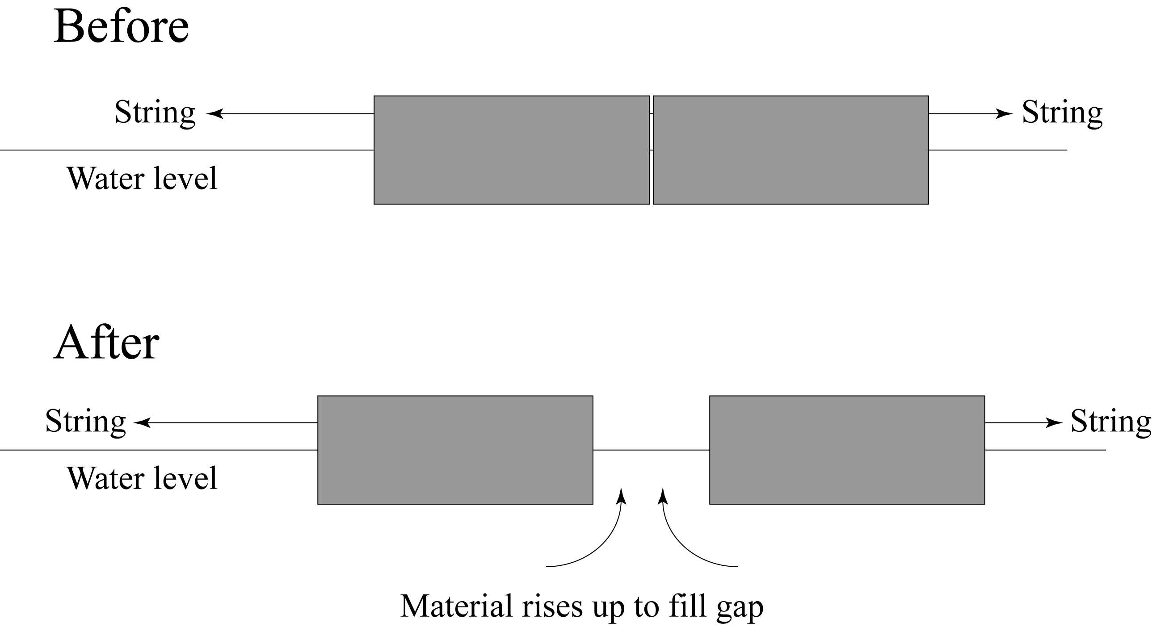
Downward convection currents take the form of cold dense low-buoyancy subducting oceanic plates that sink down through the mantle, eventually heating up enough that they lose their brittle rigid nature and become so pliable that they are indistinguishable from the rest of the mantle. Why are oceanic plates denser than the mantle? See the lecture on convection and plate tectonics.

Final Thoughts on the Link Between Plate Tectonics and Convection
The book and I (and many others) have often referred to mantle convection as the driving mechanism for plate movement. Perhaps that isn’t really the best way to state it. Perhaps it would be more accurate to say that plate movement is the surface expression of the convection of the outer part of Earth, including the mantle AND the crust. In other words, plate motion isn’t some separate phenomenon caused by convection. Rather, plate motion is an essential aspect of the convection of Earth’s mantle-plus-crust.
Purposes of the Homework Assignments
1. To help you navigate through the reading and focus on the MEANING behind the words.
2. To show you what is important to understand and remember for this class, what is just an illustrative example, and what is extra information that you will not be held responsible for.
3. To help you connect what you do in lab and lecture with the reading in the textbook.

Instructions: Before reading each section of the book or packet, read the questions and comments below that pertain to that section. As you read, fill in any blanks provided on these pages. Write additional notes as you like.

A Reminder of the Policy on Collaboration: We allow and expect you to help each other learn the course material; thus we encourage you to collaborate on homework. Collaboration entails the active participation of all group members. All members must write their own answers in their own words and make their own diagrams. Regarding weekly homework…
1) Direct quotes from the book are fine, as long as you put quotation marks around each quote.
2) If we find two or more papers with one or more identical answers, especially on the “thought” questions, we will award a zero score to all papers involved.
There are two exceptions to this policy:
a. If a question can be answered with a word or short phrase, identical answers are okay.
b. Identical quotes from the book are okay.

Chapter 8: Earthquakes and Earth's Interior

What is an Earthquake? (p. 220–223)

A. Ways of describing the location of an earthquake (see Figure 8.2 on p. 221):
What is the focus of an earthquake?
What is the epicenter of an earthquake?

B. Earthquakes and Faults
Seismic waves are analogous to the waves “produced when a stone is dropped into a calm pond” (p. 220). The analogy is not perfect, however. Most earthquakes are not caused by objects (such as giant meteors) falling on the earth's surface. Large falling meteors do, in fact, cause seismic waves. In addition, a few earthquakes are caused by bomb blasts or volcanic eruptions. But most earthquakes occur along faults.

1. What is a fault?

2. How does plate tectonics theory help explain motion along faults?

Supplemental Readings on Earthquakes

C. Elastic Rebound: Harry F. Reid's Elastic Rebound Theory is THE theory that explains the vast majority of earthquakes. The textbook explains this theory very briefly on p. 222–223. But I would like you to gain a deeper more thorough understanding of the theory. So, in addition to reading the textbook and doing the lab activity on earthquakes, please also read the supplemental readings on earthquakes on pages A–1 through A–6 of this course packet. Questions 1–6 below are based on the supplemental readings.
1. What is the difference between stress and strain?

2. Describe an example of elastic strain and release of that strain in everyday life. Please describe an example OTHER THAN the rubber band example described on p. A–1.

3. Describe an example of permanent strain in everyday life.

4. Briefly describe Mr. Reid's elastic rebound theory in your own words.

5. The bottom diagram on p. A–2 shows that, after the earthquake, the “newer” survey line ended up rebounding “beyond straight.” In other words, it actually ended up bent in the opposite direction of what it had been just before the earthquake. Explain how this could occur. (Hint: carefully study the diagrams on pages A–5 and A–6)

6. Plate motion along the San Andreas fault is about 5 cm (2 inches) per year. Do Las Vegas and Los Angeles (1) move relative to each other 5 cm EACH year, or do they (2) stay locked together most of the time but move suddenly in big jumps (several m) whenever there is an earthquake along the southern part of the San Andreas fault? Explain the reasoning behind your answer.
Helpful hint: Look carefully at the diagram on p. A–4. Note the typical width of the gray region.

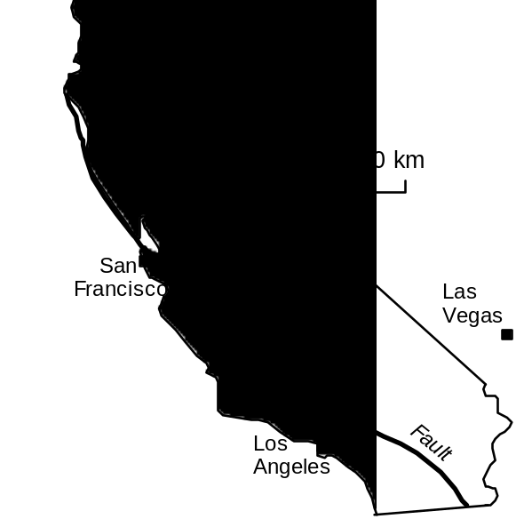

D. The San Andreas Fault System: (Read p. 224–225 of the textbook. See also Figure 10.A on p. 292 for a map of the San Andreas fault and read Box 10.1 on p. 292–293 for further information.)

1. When an earthquake happens, is there fault motion along the entire San Andreas fault? Explain (Hint: the San Andreas fault is over 1000 km long).

2. If you had to live along the San Andreas fault, would you rather live along a segment that exhibits creep or would you rather live along a segment that exhibits stick-slip motion? Explain.

YOUR Chance to Predict an Earthquake
Imagine you are working for a large corporation that would like to establish an office in Palm-dale, CA. Palmdale is attractive because it is close to Los Angeles yet real estate is relatively inexpensive. However, Palmdale is right on the San Andreas fault and your company is under-standably concerned about the risk of earthquakes. Your job is to assess the earthquake risk for Palmdale. Fortunately, you have stumbled upon the seismological study described below.
Summary of the Seismological Study

If we had historical records of earthquakes in California for the past 2000 years, we would be able to predict real earthquakes just like you recently did in lab for model earthquakes. Some parts of the world, such as China, do have historical records that go back that far but written records in California only go back about 200 years.
Therefore, geologists have to use indirect methods to obtain an earthquake history; these methods comprise the science of Paleo-seismology. A short segment of the NOVA Program Earthquake documents the paleoseismological work of Dr. Kerry Sieh (from Cal Tech).
Dr. Sieh studied a segment of the San Andreas fault just east of Palmdale (see map). This segment last moved during the 1857 Fort Tejon earthquake (estimated magnitude 8.3). Dr. Sieh excavated trenches across the San Andreas fault near a small dry creek called Pallett Creek. He found many layers of sediment that had been offset by the San Andreas fault. By carefully documenting how the fault offset each layer and by using carbon-14 dating to figure out the age of each layer, Dr. Sieh was able to determine the approximate date of every very large earthquake to hit the Pallett Creek segment of the San Andreas fault for the past 1300 years.

Dr. Sieh's work revealed that 10 major earthquakes had occurred on the Pallett Creek segment of the San Andreas fault in (approximately) the following years:

1. 700 A.D.
2. 750 A.D.
3. 800 A.D.
4. 1000 A.D.
5. 1050 A.D.
6. 1100 A.D.
7. 1350 A.D.
8. 1480 A.D.
9. 1812 A.D.
10. 1857 A.D.
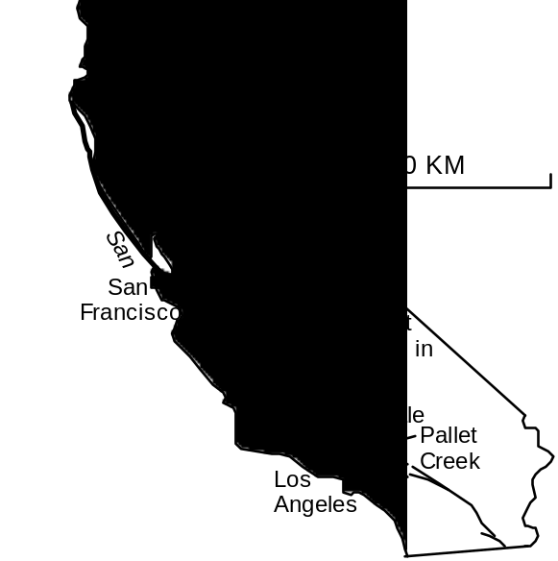

*This was not the first earthquake to occur on the Pallett Creek segment of the San Andreas fault. It is simply the earliest earthquake for which Dr. Sieh could find evidence.
Analyzing the Data
In order to be able to evaluate the earthquake hazard for Palmdale, you will have to do some statistical analyses of the data and make some graphs (bosses LOVE graphs). The purpose of these analyses is NOT just to insert the “correct numbers” in all of the empty boxes in the tables. The purpose of the analysis is to work with the numbers in order to more fully grasp their significance.
1. Calculate the average time interval between earthquakes: Complete the table on the next page.
2. Graph the ”Frequency Distribution” for the Lengths of the Time Intervals Between Quakes
Fill in boxes on the blank graph provided on the next page to construct a bar graph that shows the “frequency distribution” for the lengths of the time intervals between earthquakes. The best way to explain how to do this is with an example:
Example:  Here is what the graph would look like if the time intervals between earthquakes had been 36, 73, 82, 106, 132, 147, 169, 188, 288, and 276 years. | 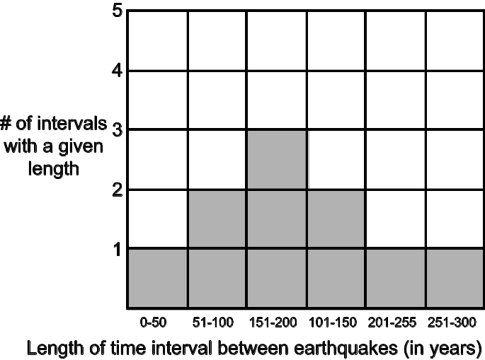
3. Calculate some interesting numbers and dates
a. How many years has it been since the last major earthquake?
b. If the current interval between major earthquakes had been a perfectly “average” one, when should the next major earthquake have occurred?

c. According to the table, how long was the LONGEST interval between earthquakes?

d. Assuming a best case scenario (i.e. the interval we are currently in is just as long as the longest one known), when will the next major earthquake occur?

e. Assuming a more realistic scenario, if we average all the time intervals that are at least as long as the one we are currently in, when will the next major earthquake occur?

Interval Number | Date of Earthquake at beginning of interval | Date of Earthquake at end of interval | Length of Interval  (in years)
1 | 700 A.D. | 750 A.D.
2 | 750 A.D. | 800 A.D.
3 | 800 A.D. | 1000 A.D.
4 | 1000 A.D. | 1050 A.D.
5 | 1050 A.D. | 1100 A.D.
6 | 1100 A.D. | 1350 A.D.
7 | 1350 A.D. | 1480 A.D.
8 | 1480 A.D. | 1812 A.D.
9 | 1812 A.D. | 1857 A.D.
Average Time Interval between Earthquakes
(Add all nine time intervals together and then divide by 9)
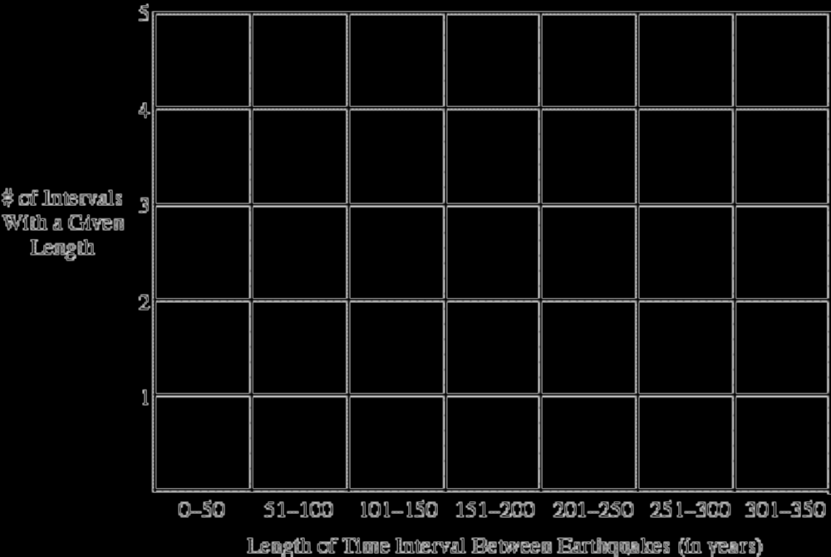
Reference: Sieh, K., Stuvier, M., and Brillinger, D., 1989, A more precise chronology of earthquakes produced by the San Andreas fault in southern California: Journal of Geophysical Research, v. 94, p. 603–623.
4. Make a recommendation: Do you think your company should establish an office in Palmdale? Use the data, numbers and graphs to justify your answer. Be as specific as possible. (Note: there is no one right answer to this question but there are a lot of possible inadequate answers.)

Chapter 8: Earthquakes and Earth's Interior

Earth’s Interior (p. 238–241):

A. Formation of Earth’s Layered Structure
Planet Earth became layered by composition very early in Earth’s history. In explaining why Planet Earth became layered by composition, the book states that “Melting produced liquid blobs of heavy metal that sank toward the center of the planet.” Please write a better explanation, using terminology more accurate than “heavier.”

B. Earth’s Internal Structure
1. The Earth is divided into three major layers by chemical composition (See Figure 8.25 on p. 239 for a good diagram of these layers). In order from the outside in, these layers are…
a. : a thin outer layer of rock and soil.
b. : a thick layer of dark dense rock that makes up most of the earth's volume. The rocks that make up the mantle are solid and crystalline except for some relatively small pockets of molten rock (magma) near the top of this layer.
c. : a sphere of metal, probably mostly iron and nickel.
2. Which of these three layers is the densest? The least dense?
3. Lithosphere and Asthenosphere
a. Lithosphere (the “plates”)
i. What major compositional layers (or portions thereof) form the lithosphere?
and .

ii. How thick, on average, is the lithosphere?

b. Asthenosphere (the “plates” move around on the asthenosphere like ships sailing the ocean)

What major layer is the asthenosphere part of?
c. In terms of stiffness and strength, how is the lithosphere different from the asthenosphere?

d. The mantle part of the lithosphere and the asthenosphere are made of the exact same kind of rock (peridotite). So then why is the asthenosphere so much weaker than the lithosphere?

3. Lower Mantle
a. The lower mantle is made of the same type of rock as the asthenosphere is. So then why is the lower mantle stronger than the asthenosphere?

b. Which layer is thicker, the asthenosphere or the lower mantle? (Hint: see Figure 8.25)

4. Inner and Outer Core: How is outer core different from the inner core?

C. Probing Earth’s Interior: What kind of data do seismologists use to determine what the Earth's deep interior is like? Explain.

D. Making sense of all these layers: The next page shows a partial view of the Earth cut through the center. A small box in the upper right hand corner of the diagram shows an enlargement of the outermost layers of the Earth. In order to construct a clear understanding of these layers in your head, color and label the main diagram and the one in the box as follows:
• Color the core yellow
• Color all layers of the mantle red
• Color the crust green
• Label the asthenosphere and the lithosphere

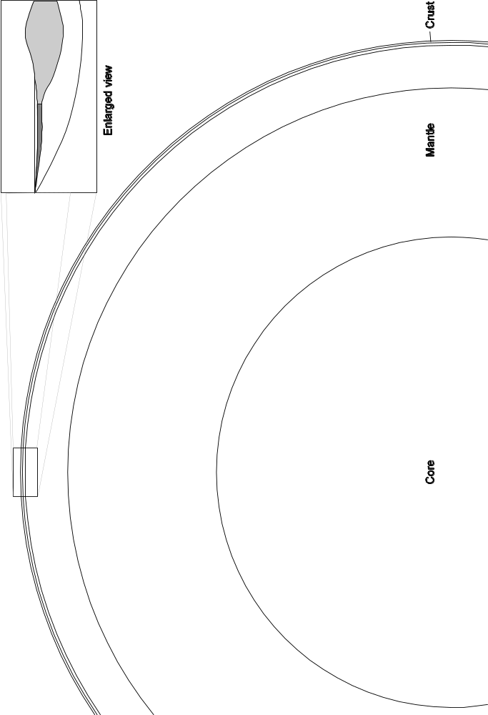
Supplemental Readings on Plate Tectonics and Convection

The questions below are based on the first part of the Supplemental Readings on Plate Tectonics and Convection (pages A–7 through A–9 of the course packet)

Thermal Expansion (p. A–7):
A. As the temperature of water decreases, its volume increases / decreases .
(Circle the correct answer)
B. Explain what happens at the molecular level to allow water to contract.

Density (p. A–7 and A–8):
A. What is the density of 1000 g of water at 25°C?*
What is the density of 10 tons of water at 25°C?
Explain the reasoning behind your answers

B. Which has the greater density, 1 pound of lead or 100 pounds of feathers? Explain the reasoning behind your answer.

C. If you take a well-sealed bag of potato chips up into the mountains, it will expand (We'll learn why later this semester; don't worry about it now). In other words, the volume of the air in the bag of potato chips will increase WITHOUT the addition of any air molecules--remember, the bag of potato chips is well-sealed. As a result of the increase in volume (with no increase in mass), the density of the air in the bag of potato chips will
increase / decrease (Circle your answer.).
Explain the reasoning behind your answer.
Changes in Density with Temperature (p. A–7 and A–8):
A. Water: based on the numbers in the table on p. A–8…
1. As the temperature of water increases, its density increases / decreases .
2. Fully and clearly explain why this happens.

B. Ice: based on the numbers in the table on p. A–8…
1. As the temperature of ice increases, its density increases / decreases .
2. As a piece of ice that gets so warm that it melts and turns into water, what happens to its density?

3. What is making it possible for this density change to happen?

Chapter 7: Plate Tectonics

Plate Tectonics: The New Paradigm (p. 194–195 of the textbook):
A. Earth’s Major Plates
1. How fast, on average, do plates move?

2. Plate movement generates which of the following phenomena? (Circle all correct answers.)

Floods / Earthquakes / Hurricanes / Volcanoes / Mountains / Ocean waves
B. Plate Boundaries (p. 195)

1. What kind of data did geoscientists first use to outline the plate boundaries? (Hint: see Figure 8.12 on p. 229)

2. Name and briefly describe the three types of plate boundaries.

a.

b.

c.

Study Figure 7.10 on p. 196–197. Note the following aspects of this diagram:
(a) Each plate is shown in a different color. The darker shade of each color is dry land--the continents.
(b) This map shows topography as “shaded-relief.” The flat shallow parts of the oceans around the edges of the continents are areas of continental crust that is flooded by sea-water. The steep drop-offs on the edges of these regions are the places where continental crust meets oceanic crust.
(c) The black lines are plate boundaries.

3. Where is the eastern margin of the North American plate?

4. Where is the western margin of the Nazca plate?

5. Is it possible to have both continental and oceanic crust on the same plate?
If you answered “no,” explain why not. If you answered “yes,” give three examples.

6. What kind of plate boundary is located along the west coast of South America?

7. What kind of plate boundary is located along the Mid-Atlantic Ridge?

8. Can one plate have several types of plate boundaries?
If you answered “no,” explain why not. If you answered “yes,” give one example.

9. Can individual plates change size?
If you answered “no,” explain why not. If you answered “yes,” give three examples.

C. Divergent Boundaries (be sure to study Figures 7.11, 7.12 and 7.13)
1. Where are most divergent boundaries located?

2. What, exactly, happens at divergent plate boundaries that are located in an ocean?

3. Another name for this process is
4. Can divergent plate boundaries form in the middle of a continent?
D. Convergent Boundaries
1. Basic Characteristics: Most convergent plate boundaries are marked by deep-ocean trenches and subduction zones.

- What is a deep-ocean trench? (See p. 376 in Chapter 13)

- Why are deep-ocean trenches located at convergent plate boundaries? (back to p. 200)

- What is a subduction zone?

- What causes subduction?

- Will oceanic lithosphere subduct? Why or why not?

- Will continental lithosphere subduct? Why or why not?

2. Oceanic-Continental Convergence (Study Figure 7.15A on p. 201)
a. Wherever there is oceanic/continental convergence, there is a chain of volcanoes, called an “arc” (because it is often arc-shaped). On which plate will you find the volcanoes?
Oceanic / Continental.
b. Study Figure 7.10 on p. 196–197. Recall that the black lines are plate boundaries. Note that, at convergent plate boundaries, the teeth “point” in the direction of motion for the subducting plate. For example, the Nazca plate is subducting into the mantle underneath the South American plate.
There are many volcanic mountain chains that have been formed by oceanic/continental convergence. For example, the Andes Mountains of South America are formed by the subduction of the Nazca plate underneath the South American plate.
Name two other places where you would expect to find volcanic mountain chains caused by oceanic/continental convergence (If you are weak on place names, consult any world atlas). For each of these two places, name the overriding plate and the subducting plate. Record your answers in the table below.
Place Name | Overriding Plate | Subducting Plate
West Coast of South America | South American | Nazca
3. Oceanic-Oceanic Convergence (Study Figure 7.15B on p. 201)
a. Wherever there is oceanic/oceanic convergence, there is a chain of volcanic islands (an “island arc”). On which plate will you find the volcanoes?
Subducting plate / Overriding plate
b. Compare Figures 7.10 (p. 196–197) and 7.14 (p. 200).
i. Which of these island chains were formed by Oceanic/Oceanic convergence?
Aleutian Islands (southwest of Alaska) / Hawaiian Islands (middle of Pacific Ocean)
ii. For the island chain that is NOT being formed by Oceanic/Oceanic plate convergence, explain how you know that it is NOT being formed that way.

iii. For the island chain that IS being formed by Oceanic/Oceanic plate convergence, name the plate that is being subducted.

Name the overriding plate

4. Continental-Continental Convergence (Study Figure 7.15C on p. 201 and Figure 7.16 on p. 202)
a. Describe the sequence of events that can result in the convergence of two continents.

b. Study Figure 7.15 on p. 201. Both oceanic-continental and continental-continental convergent plate boundaries have mountains associated with them. How do the mountains associated with the two different kinds of plate boundaries differ from each other?

E. Transform Boundaries (Study Figure 7.18 on p. 204 and Figure 7.19 on p. 205)
1. Is crust created or destroyed at transform boundaries? Explain.

2. Name one major transform plate boundary

Chapter 7 and Supplemental Readings on Plate Tectonics and Convection

The questions below are based on the last part of the Supplemental Readings on Plate Tectonics and Convection (pages A–9 through A–12 of the course packet) and the section entitled What Drives Plate Motion on pages 211–213 in the textbook.
A. Why does “young” oceanic lithosphere float on the asthenosphere, forming mid-ocean ridges? In your answer, be sure to discuss the densities of the young oceanic lithosphere and the asthenosphere and the implications of these for the relative buoyancies of the two.

B. Why does “old” oceanic lithosphere form deep ocean basins and, when given the chance, will easily subduct, sinking down into the asthenosphere?

C. According to the best current model for mantle convection, are all upwelling mantle convection currents located directly below divergent plate boundaries? Explain.

D. According to the best current model for mantle convection, are all downwelling mantle convection currents located at convergent plate boundaries? Explain.

Chapter 2: Rocks: Materials of the Lithosphere

Igneous Rocks: “Formed by Fire” (p. 54–62)
A. Magma
1. What is magma?
2. Where does magma originate?
3. What does magma consist of?

a.

b.
4. Why does magma “work its way (upward) toward the surface?”

5. What is lava? (The definition is in the glossary at the back of the book)

B. Volcanic Gases
Supplemental Information: As the book states, “Sometimes lava is emitted as fountains that are produced when escaping gases propel molten rock skyward.” What are these gases and why would they “escape” the lava? When magma is deep underground, its gas component is dissolved. When gas is dissolved in magma (or any other liquid), each individual gas molecule is completely surrounded by molecules of the liquid. The gas molecules occupy the spaces between the molecules of the liquid, so the gas itself takes up almost no space.
You have experienced this phenomenon all of your life with carbonated drinks. The thing that makes a drink “carbonated” is dissolved carbon dioxide gas. The carbon dioxide gas that is dissolved in beer takes up almost no space as long as the beer is sealed in a bottle or can; when you look at a sealed bottle of beer, you don't see bubbles of gas because the gas is still dissolved in the beer.
However, once gas is no longer dissolved in a liquid, individual molecules of the gas gather together to form bubbles. These bubbles of gas take up a lot more space than the same gas took up when it was dissolved in the liquid. These gas bubbles rise rapidly through the liquid and into the air above the liquid.
Now, what would make a gas “escape” from the liquid it was dissolved in? You know that the gas in beer will stay dissolved in the beer as long as the beer bottle is sealed. But when you open a beer, a foam of bubbles forms almost instantly and new bubbles keep rising as you drink the beer. Why did the gas suddenly “escape” from the beer? Well, the pressure inside a sealed beer bottle is higher than the pressure outside of the sealed beer bottle. As soon as you open the seal, the pressure inside the bottle decreases very quickly--that is why the bubbles form. Gas can stay dissolved in a liquid as long as the liquid stays under high pressure. When that pressure is released, the gas cannot remain dissolved in the liquid and it has no choice but to “escape” from the liquid, and form bubbles.
Now that you thoroughly understand beer, you may be wondering how all of this information relates to magma. You know that when you swim to the bottom of a pool or go scuba diving in the ocean, you feel more pressure (usually in your ears) on you as you go down. The same is true in rock (only even more so because rock is denser than water). So, as long as magma is deep within the earth, it is under great pressure and the gas it contains remains dissolved. However, when that magma rises up toward the surface, the pressure on it decreases. The gas can no longer remain dissolved in the magma so it forms bubbles that rise rapidly through the magma and, if there is an opening, into the air above.
If these bubbles form and rise VERY rapidly, they may shoot up out of the volcano, taking a great deal of magma with them. Voila! A spectacular fountain-type of volcanic eruption (See, for example, page 247, Fig. 9.5 on p. 252, and Fig. 9.14 on p. 258.).

Thought Questions:
a. As the pressure decreases and bubbles of gas form in magma (or beer), why do the bubbles rise up? Why don't the bubbles just stay where they are?

b. Sometimes when lava erupts out of a volcano, it forms a beautiful fountain of red-hot liquid lava. The lava falls to the ground and forms lava rivers flowing away from the fountain. This is what often happens on Kilauea on the Big Island of Hawaii (you saw—or will see—a videotape of such a fountain in lab). What causes a lava fountain to form?

c. Sometimes, volcanoes explode catastrophically, spraying lava far up into the atmosphere. The droplets of lava solidify instantly, forming a gray cloud of volcanic ash. This is what happened on Mt. St. Helens in 1980 and on Mt. Pinatubo in 1991.
What could cause such an eruption?

C. The two main categories of igneous rock (back to page 54 of your textbook)

1. Volcanic (Extrusive):

2. Plutonic (Intrusive):

D. Magma Crystallizes to Form Igneous Rocks
1. How do the ions that make up the liquid portion of a magma body behave?

2. What happens to these ions during the process of crystallization?

3. When a magma cools very slowly, the crystals formed are large / small (circle the correct answer). Explain why.

4. When a magma cools quickly, the crystals formed are large / small (circle the correct answer). Explain why.

5. What happens when magma is quenched almost instantly?

6. Thought question: How is the internal structure of very tiny crystals different from the internal structure of glass?

E. Classifying Igneous Rocks
1. Igneous Textures: How is the term texture used, when applied to an igneous rock?

2. Igneous rocks that form when magma crystallizes at or near the Earth's surface
a. Describe the texture of these rocks (See Fig. 3.5A on p. 56 and Fig. 3.11 on p. 59).

b. Why do these rocks have this texture?

c. Volcanic rocks often have rounded holes in them (See Figure 3.6 on p. 56). Explain how these holes form.

3. Igneous rocks that form when magma crystallizes far below the Earth's surface
a. Describe the texture of these rocks (See Fig. 3.5B on p. 56 and Fig. 3.11 on p. 59).

b. Why do these rocks have this texture?

c. How long does it take to crystallize a large mass of magma located at depth?

4. Igneous rocks that form when magma begins to crystallize far below the Earth's surface but then suddenly erupts out of a volcano
a. Describe the texture of these rocks (see Figure 3.5D on p. 56)

b. What is the name for this type of texture?

c. Why do these rocks have this texture?

5. Igneous rocks that form when magma is ejected into the atmosphere and quenched quickly
a. Describe the texture of these rocks (see Figure 3.7 on p. 57).

b. Why do these rocks have this texture?

c. The special case of pumice (see Figure 3.8 on p. 57):
i. Describe the texture of pumice.

ii. Why does pumice have this texture?

iii. How is the texture of pumice similar to and different from the texture of obsidian?

Chapter 9: Volcanoes and Other Igneous Activity

Origin of Magma (p. 269–271)
A. Generating Magma from Solid Rock
1. Introduction
a. “The crust and mantle are composed primarily (i.e. 99.9%) of”

solid rock / magma (melted rock)

b. Much of the earth's core is fluid. Is this where magma comes from? Why or why not?

c. Where does magma originate from?

2. Role of Heat:
a. You can melt a rock by increasing / decreasing (circle the correct answer) the temperature of the rock.
b. Name one source of heat to melt crustal rocks
c. Does the addition of heat cause much magma generation in Earth’s mantle?

3. Role of Pressure:
a. You can melt a rock (if it’s already pretty hot) by increasing / decreasing (circle the correct answer) the confining pressure on the rock.

b. As confining pressure increases, melting temperature increases / decreases .

Here is a VERY important additional piece of information: When a rock melts, it expands--even if the temperature does not increase. In other words, when a rock melts, the magma generated takes up more space than the unmelted rock did.
c. Thought Question: Using this information, think of a logical explanation for why “an increase in the confining pressure increases a rock's melting temperature.” (p. 270)

d. The pressure on rock increases / decreases (circle the correct answer) whenever the rock ascends to higher levels. Explain why.

e. A hot rock that maintains the same temperature will tend to melt as it descends /
ascends (circle the correct answer) through the crust. Explain.

4. Role of Volatiles: You can melt a rock (if it’s already pretty hot) by
increasing / decreasing (circle the correct answer) the water content of the rock.

5. Summary: List the three sets of conditions that can cause rocks to melt.

a.

b.

c.

Plate Tectonics and Igneous Activity (p. 271–277)
A. Igneous Activity at Convergent Plate Boundaries (In addition to reading this section, carefully study Figure 9.32 on p. 270 and Figures 9.34A and 9.34E on p. 274)
1. Which of the three causes of melting is active at subduction zones?

2. Describe exactly how and where magma is generated at subduction zones.

Additional Information: You may be wondering how water gets into oceanic crust in the first place. Imagine the rocky ocean floor sitting there under thousands of feet of water; it is made of basalt. Even the tiniest cracks in this basalt will let water seep through. As the water seeps through the basalt, the water will “react” with the rock. In other words, some of the water molecules will incorporate themselves into the crystal structure of certain mineral grains in the basalt, forming a different type of mineral (for example, water is added to olivine to form serpentine--we will study these minerals soon).
Now, imagine this “wet” altered basalt being subducted (See Fig. 9.32 on p. 270). As it goes deeper and deeper, into the asthenosphere, it gets hotter and hotter, and the pressure on it becomes greater and greater (Why? Simply because pressures and temperatures increase with depth), causing the basalt to undergo metamorphism. The water-rich minerals in the basalt are no longer stable. They recrystallize to form new minerals that are stable (this is one of the processes of metamorphism), releasing the water.
3. Thought Question: Why does the water “migrate upward into the wedge-shaped piece of mantle located between the subducting slab and overriding plate?” Why doesn’t it migrate downward or sideways?

B. Igneous Activity at Divergent Plate Boundaries (p. 276) (In addition to reading this section, carefully study Figure 9.31 on p. 270 and Figures 9.34B and 9.34F on p. 275)
1. Which of the three causes of melting is active at divergent plate boundaries?

2. Describe exactly how and where magma is generated at seafloor spreading ridges.

3. What is the cause of mantle melting at continental rift zones like the East African Rift?

C. Intraplate Igneous Activity (p. 276–277) (In addition to reading this section, carefully study Figure 9.34C on p. 274, Figure 9.34D on p. 275, and Figure 9.36 on p. 276)
1. At centers of intraplate volcanism (such as Yellowstone National Park or Mt. Kilauea in Hawaii), the mantle is different from intraplate locations where there are no volcanoes (such as Kansas or Florida). What is different and how does it cause volcanism?

2. What is a hot spot?

3. Which of the three causes of melting is active at hot spots?
D. Summary (See Figure 9.34 on p. 274–275): List the three major “zones of volcanism,” i.e. list the three tectonic settings in which the Earth’s mantle melts to form magma.
1.
2.
3.

E. Melting of Continental Crust—can occur in ANY of the above three tectonic settings (See the “Role of Heat” paragraph on pages 269–270, Figures 9.34 D, E and F on pages 274–275)
What could cause melting of continental crust? In other words, which of the three causes of melting (see question 5 on p. A–36) is involved and how, specifically, does this cause of melting operate in continental crust?

Chapter 7: Plate Tectonics

Hot Spots (p. 206–207)
A. What is the observed trend in the ages of volcanoes in the Hawaiian Islands, one famous hot spot? (Be sure to study Figure 7.21 on p. 207)

B. Mantle rocks below Hawaii are melting. What is happening there to cause this melting?

C. Explain the plate tectonic cause of the observed trend in ages of the volcanoes on the Hawaiian Islands (in other words explain the cause of the trend you described in question A above)--in addition to reading the text, take a close look at Figure 7.21 on p. 207.

Objectives
When you have completed this lab and Homework Assignment #1, you should be able to
1. define earthquake fault and explain how earthquake faults cause earthquakes.
2. describe how and where energy accumulates between earthquakes and define the type of energy that is stored.
3. describe how and why some of this accumulated energy is released during an earthquake.
4. explain Harry F. Reid's Elastic Rebound Theory and use it to explain the behavior of the earthquake model you will use in this lab.
Introduction

An ideal way to study earthquakes would be to set up huge numbers of monitoring devices near an earthquake fault and then watch hundreds of major earthquakes, documenting the amount of fault offset, any bulging or stretching of the crust near the fault, the time intervals between earthquakes, etc. We would watch to see what kinds of changes in the shape of the earth take place between earth quakes and, most specifically, what happens right before a major earthquake. Unfortunately (for seismologists; fortunately for people who live near earthquake faults), earthquakes don't happen very often. Even on major faults, such as the San Andreas fault, any given segment of the fault will only move once every 30-300 years. Thus this ideal study of earthquakes would take far too long and, incidentally, would be extremely expensive. So, some seismologists (people who study earthquakes) study the behavior of foam rubber, springs and other common everyday ordinary objects instead. Why? These common everyday objects are small enough to fit easily into a lab room, they can move much faster than the Earth's crust, and they really do behave, at least approximately, like the Earth's crust.
As amateur seismologists, we will use the simple device illustrated below to model the behavior of the Earth's crust at and near an earthquake fault. Keep in mind that this device is not a perfect scale model; it is simply an analogy.

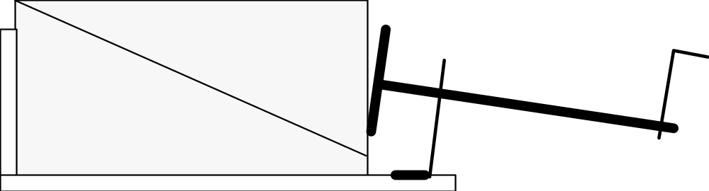
Starting Position for Earthquake Model
Each part of the device behaves, in some ways (not all), like a feature of the Earth's crust:

Part | Represents and behaves like …
Two wedge-shaped pieces of foam rubber | The rocks near an earthquake fault. Imagine that each mm of foam rubber represents one meter of rocks in real life.
Surface where the two pieces of foam rubber touch each other | The earthquake fault; this type of fault (in which the rocks on one side of the fault ride up and over the rocks on the other side of the fault) is called a thrust fault. The two other common types of faults are normal faults and strike-slip faults (see p. 288–291 in the textbook).
Metal plate that pushes against one of the pieces of foam rubber | Force that is pushing on the rocks; for example, a colliding plate.

Activity #1: Observing the Model in Operation
Materials: two wedge-shaped pieces of foam rubber
earthquake-modeling device
sheet of paper, cut to fit along the “fault” between the two pieces of foam rubber
ruler, divided into cm and mm

Activity
1. Arrange the pieces of foam rubber and the apparatus to match the “starting position,” shown on the previous page. Place the sheet of paper between the two foam rubber pieces, centered on the “fault” surface. Line up the vertical lines that are drawn on the sides of the foam rubber pieces. The device is now in the starting position, before there has been any motion on the fault.
2. Place the apparatus near the edge of the lab table so that the crank hangs over the edge. Work as a team as follows:
Team member #1: gradually turn the crank. The turning of the crank represents the passage of time. Imagine that each turn on the crank represents 10 years.
Team member #2: hold the apparatus down so that it cannot move (much)
Team member #3: hold down the bottom piece of foam rubber (it may want to gradually lift up as you turn the crank).
Team member #4: if necessary, hold onto the metal plate to prevent it from turning
3. Slowly turn the crank clockwise as far as it will go. As you turn, watch for any “earthquakes”; i.e. motion on the fault (you can see this most easily by looking at the vertical lines drawn on the foam rubber) and any changes in the shapes of the two pieces of foam rubber before and after the “earthquakes.” As you begin turning the crank, the top piece of foam rubber may move fairly smoothly. But after 10-20 turns, if the model is correctly adjusted, the top piece of foam rubber should move forward in a series of sudden jumps with no perceptible movement happening for several turns of the crank in between each pair of jumps. If your model does not behave this way, adjust the size of the paper on the “fault” as follows: If the fault remains locked, use a wider piece of paper. If the fault slips too often, use a narrower piece of paper.
Questions
1. What was happening to the shapes of the foam rubber pieces while you were turning the crank but there was no motion along the fault? Draw one or more diagrams to illustrate your answer.

2. During each earthquake, the top piece of foam rubber made a very rapid change in position. Did it also undergo any rapid change in shape (this may be VERY hard to detect)? If so, describe that change in shape. Draw one or more diagrams to illustrate your answer.

3. When you were advancing the metal plate by turning the crank, you were exerting energy. Energy cannot be created or destroyed.
a. Between earthquakes, where do you suppose that energy was going? Explain.

b. During earthquakes, where do you suppose that energy was going? Explain.

4. Just before each earthquake, something “broke the camel's back” (i.e. the model “couldn't take any more” and had to give). As a group, brainstorm about what that something was that “broke the camel's back.”

Activity #2: Quantifying the Behavior of the Model
Activity
1. Turn the crank to back up the metal plate and return the apparatus to the starting position.
2. Gradually turn the crank as before, but stop IMMEDIATELY after each earthquake to record (a) the total number of turns on the crank since the experiment started and (b) the total amount of offset on both sets of vertical lines. Record these data in Columns 2 and 3 of the table below. You DO NOT necessarily have to record 18 earthquakes; just record the results of one good complete run of the experiment.
3. For each earthquake, calculate a) the number of turns on the crank since the last earthquake and b) the amount of fault offset that took place during the earthquake (measure offset with as ruler placed ALONG the fault line). Record the results in Columns 4 and 5 below.
4. Make a graph of columns 2 and 3 on page A–43. Follow instructions carefully!

 | Data to Record |  |  | Calculations to Make
Column #1 | Column #2 | Column #3 |  | Column #4 | Column #5
Earthquake # | Total # of turns on crank since the experiment | Total fault offset since experiment started (in cm) |  | # of turns on crank since last | Amount of fault offset that occurred during the earthquake (in cm)
 | started | Line 1 | Line 2 | earthquake | Line 1 | Line 2
1
2
3
4
5
6
7
8
9
10
11
12
13
14
15
16
17
 |  | Average
 |  | Highest
 |  | Lowest

Graph Showing Cumulative Fault Offset vs. the Number of Turns of the Crank
Instructions: Draw two continuous (but not at all smooth) lines on the graph, showing the total amount of fault offset for each line that had accumulated for each # of turns of the crank. For example, you should be able to use the graph to determine exactly how much offset had accumulated by the time you had turned the crank 50 times.
Helpful hint: When you ran the experiment, the offset happened in sudden jumps, alternating with periods of stability. Be sure this pattern is reflected on the graph.

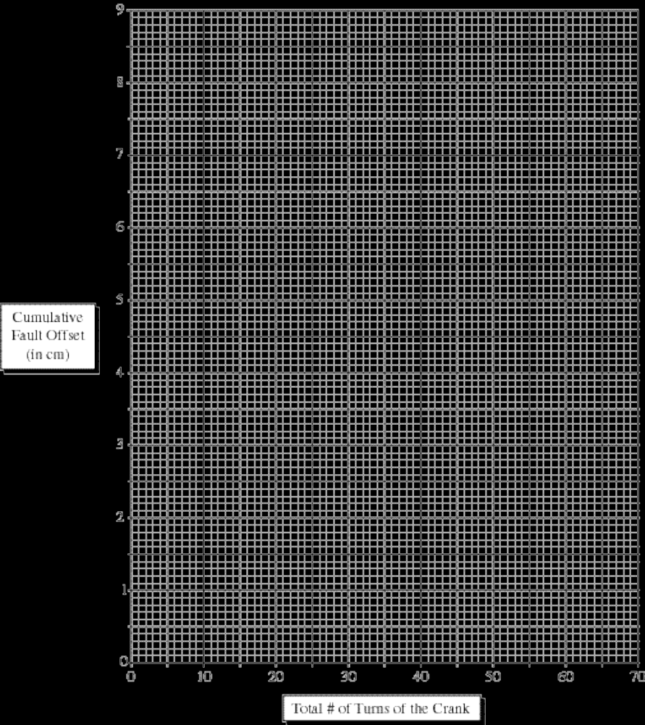

Questions:
1. Average columns 4 and 5 of the table on p. A–42. Find the highest and lowest value in each of the two columns. Record your results in the appropriate blanks at the bottom of the table.
2. Use your data from Column 4 of the table on p. A–42 to complete the bar graph below. This graph will show the “frequency distribution” for the lengths of the time intervals between earthquakes. In other words, graph the number of times it took 1 crank to get to the next earthquake, then 2 cranks, 3 cranks, etc. For example, if there are five 2's in column 4, fill in five boxes above the number 2 on the bottom of the graph.
Example:
Here is what the graph would look like if the time intervals between earthquakes had been 36, 73, 82, 106, 132, 147, 169, 188, 288, and 276 years.
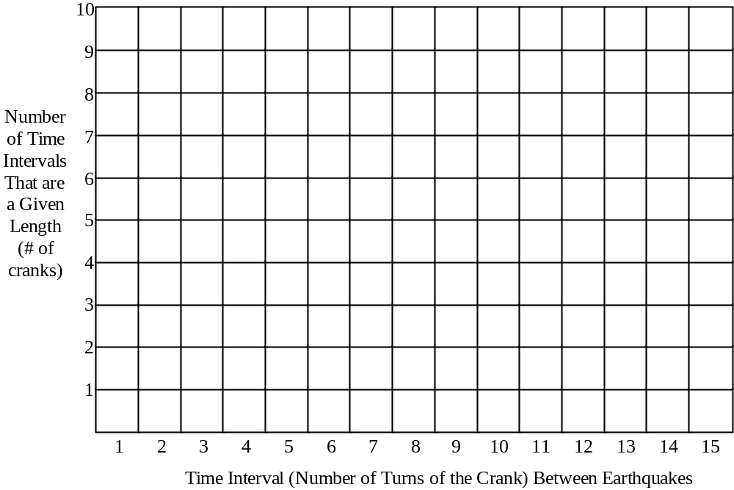
Bar Graph of the Different Time Intervals Between Earthquakes
3. The time interval between earthquakes is also known as the earthquake recurrence interval. According to your bar graph on the previous page, what was the most common recurrence interval?
(Hint: for the example bar graph on the previous page, the most common recurrence interval was 101–150 years)

For the Aficionado: Seismosurfing on the World Wide Web
World-Wide Earthquake Locator (Locations of Recent Earthquakes)
http://earthquake.usgs.gov/
Maps of locations of recent (past 72 hours) earthquakes in California and Nevada
http://earthquake.usgs.gov/eqcenter/recenteqsus/Maps/special/California_Nevada.php
Lots of Information on Earthquakes, Especially in California
http://quake.wr.usgs.gov/

Introduction
One of the four themes for this course is “Density, Buoyancy, and Convection.” These three important concepts help explain why the crust floats on the mantle, the tectonic plates move about, magma--which forms at great depths-- rises to the surface, the ocean has currents, the wind blows, and clouds form. The knowledge you gain in today's lab will serve as a foundation for much of the rest of the course.
Objectives
When you have completed this lab, you should be able to…
- describe how the density of a substance affects its buoyancy.
- describe how the temperature of a substance affects its volume.
- describe how the mass and volume of a substance determine its density.
- explain how, why and under what conditions convection occurs.
- discuss how convection serves as an effective mechanism for transporting heat energy.
Activity #1: A Look at Convection
Materials: Glitter lamp  Activity: Turn on the glitter lamp. It is powered by a small light bulb in the base of the lamp. Note that the glitter pieces do not move independently of the fluid. Rather, they float passively in the liquid; their motion reveals the motion of the liquid.  Observation Question: Write a written description of the currents of motion you see in the lamp (the pattern of fluid motion formed by these currents is called convection). Also draw the currents on the adjacent diagram. | 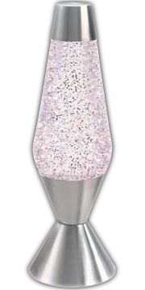
Lab Activity #2: Comparison of Motor Oil and Corn Syrup
Introduction: In the first activity, you observed the phenomenon of convection. The rest of this lab will consist of a series of activities that will help you construct an understanding of how and why convection occurs. The concepts you encounter in the various activities will build on each other to form a coherent package.

Materials: 1 clear plastic bottle containing corn syrup (light colored) and SAE 50 Motor Oil (dark), turned upside down.

Activity: Turn over the bottle so that it is right side up. Observe what happens. When the fluids have stopped moving, turn over the bottle again so that it is upside down. Observe what happens this time. Repeat as often as needed.

Observation Question
1. Complete the three diagrams below, showing the two fluids in the bottle at the times given.
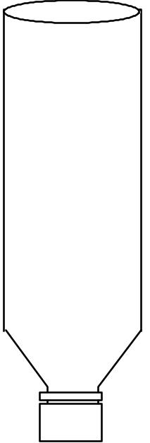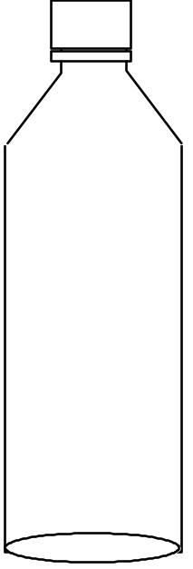
a. Before you turn over b. A few seconds after you c. After the two fluids
the bottle turn the bottle right side up have stopped moving
Thought/Interpretation Questions
2. Which fluid is more buoyant, motor oil or corn syrup? How do you know?

3. Motor oil and corn syrup have different physical properties such as color, clarity, odor, density, mass, volume. Which of these properties determines the buoyancy of the fluid? Explain.

4. Combining your answers to questions 2 and 3, explain which of the two fluids is more buoyant and why.

5. If we took this bottle of corn syrup and motor oil up in space where there is essentially no gravity, how would the results be different? Why?

Lab Activity #3: Volume Change Caused by Temperature Change*
Materials: small clear glass bottle filled with green-colored water, capped with a rubber stopper
that has a glass eye dropper inserted into the hole**
overhead transparency pen (water-soluble)
2 large (1000 ml) pyrex beakers
hot plate
crushed ice (from the styrofoam cooler near the sink, front left corner of the room)

Activity
1. On the eye dropper, use the pen to mark the level of the green water.
2. Pour about 400 ml of hot tap water into one of the pyrex beakers; place it on the hot plate and turn the hot plate on “high.”
3. Put about 400 ml of crushed ice into a large beaker. Add enough water to just cover the ice.
4. Place the bottle of green water in the ice water. Watch the level of the green water in the eye dropper. When the green water has settled to a constant level, mark that level with the overhead transparency pen.
5. Remove the beaker of hot water from the hot plate. Place the bottle of green water into the hot water. Watch the level of the green water in the eye dropper. When the green water has settled to a constant level, mark that level with the overhead transparency pen.
Observation Question
1. Complete the diagrams below, showing the various levels of the green water. The levels do not have to be perfectly accurate; they just have to convey the general idea.

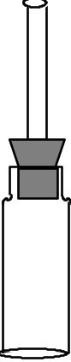
Room Temperature Ice Cold Boiling Hot
Thought/Interpretation Questions
2. Did the volume of the green water change over the course of the experiment? Explain.

3. Was any green water added or taken away as you conducted the experiment?

4. Do you suppose the mass of the green water changed over the course of the experiment? Explain.

5. Did the density of the green water change over the course of the experiment? Explain.

6. Complete the sentence below by circling the appropriate words.

Any substance will expand / contract when it is heated and expand / contract when it is cooled (circle the correct answers).

You have just formulated a general scientific law!

7. (Extra question--answer if you have extra time at the end of lab or are assigned to present this activity) Design a thermometer, using what you learned from this activity.
Lab Activity #4: Sinking and Floating Water
Materials: hot plate
2 pyrex beakers, one large (1000 ml) and one smaller
piece of white paper
large paper clip (used to hold the pill bottle down on the bottom of the beaker)
2 clear cylindrical “pill bottles,“ each with two holes in the cap
red and blue food coloring in plastic squeeze bottles, diluted to half strength
stirring stick
crushed ice (from the styrofoam cooler near the sink, front left corner of the room)
red and blue colored pencils
First Part of Activity
1. Using the hot plate and the small beaker, heat a small amount of water to boiling. Turn off the hot plate (the next activity requires an initially cool hot plate).
2. Fill the large beaker (to about 900 ml) with cold tap water and place it on the white paper. Let it rest undisturbed for a few minutes.
3. Place the paper clip in one of the pill bottles. Add about 10 drops of red food coloring. Then fill the pill bottle to the brim with boiling hot water. Place a cap on the pill bottle.
4. Holding the hot pill bottle upright by its cap (to avoid burning your fingers), gently place it in the beaker of water. Hold on to the pill bottle until it is completely submerged. Then let go and let it sink to the bottom. Using the stirring stick, gently tip the pill bottle on its side.

Observation Question
1. Observe the movement of the red (hot) water (Note: the red food coloring is simply a tracer to show the motion of the hot water--it does not move independently; it stays with the hot water). Record your observations by completing the two drawings below. Use a red colored pencil to show the red (hot) water.
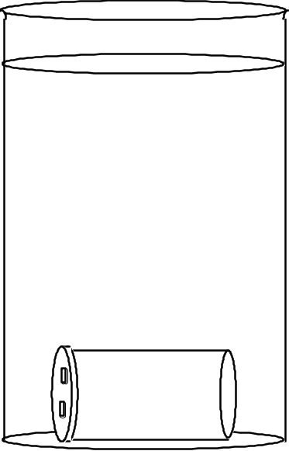
A few seconds after placing the Several minutes after placing the
pill bottle in the beaker (while the pill bottle in the beaker (after the
water is still flowing rapidly) water has mostly stopped flowing)
Thought/Interpretation Questions
2. Using the knowledge that you gained from Activities #2 and #3, explain why the red (hot) water behaved the way it did.

3. What do you think would happen if you placed a pill bottle full of ice cold water into the beaker?

Second Part of the Activity
5. Completely fill the second pill bottle with crushed ice. Add a little cold water and about 5 drops of blue food coloring. Place a cap on the pill bottle.
6. Gently place the blue (cold) pill bottle sideways in the beaker; it should float.

Observation Question
4. Observe the movement of the blue (cold) water. Record your observations by completing the two drawings below. Use colored pencils to show the red (hot) and blue (cold) water.
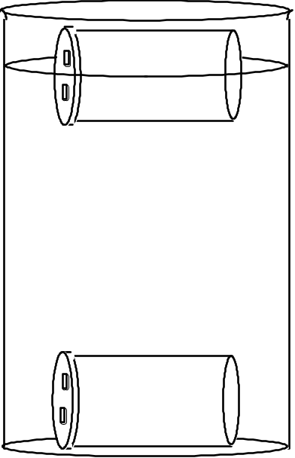
A few seconds after placing the blue Several minutes after placing the blue
pill bottle in the beaker (while the pill bottle in the beaker (after the
water is still flowing rapidly) water has been flowing for awhile)
Thought/Interpretation Questions
5. Which is more buoyant, hot water or cold water? How do you know?

6. A change in temperature must cause some other properties of the water to change, causing the difference in buoyancy that you observed. Complete the two sentences below by filling in the blanks and circling the appropriate options.
a. When the temperature of water increases, its volume decreases / increases, causing its
to decrease / increase, which causes its buoyancy to decrease / increase.

b. When the temperature of water decreases, its volume decreases / increases, causing its to decrease / increase, which causes its buoyancy to decrease / increase.

7. Does the buoyancy of water go up or down when it freezes? Why?

8. How is the freezing of a substance different from a simple change in temperature? (i.e. what extra phenomenon occurs?)

Lab Activity #5: Comparison of Two Ways to Heat a Fluid
(Heating from Above vs. Heating From Below)
Materials: 2 large (1000 ml) Pyrex beakers
thermometer
red and blue food coloring in plastic squeeze bottles (diluted to about half strength)
2 eye droppers
electric immersion heater
hot plate that has cooled to room temperature
matches
insulated gloves
Caution: DO NOT plug in the immersion heater until you have placed it in water. DO NOT remove the immersion heater from the water until you have unplugged it. If the heater is left plugged in without being immersed in water, it will heat to red hot, blow a fuse and cease to function.
1st Part of the Activity (Beaker #1):
1. Fill one large beaker with 1000 ml of cold tap water.
2. Measure the temperature of the water at the top and bottom of the beaker. Record these temperatures in the appropriate boxes of the tables on the next page.
3. Carefully place a dropper full of blue food coloring in the bottom of the beaker, disturbing the water as little as possible. The food coloring should form a dark pool at the bottom of the beaker; there should be no food coloring in the rest of the water.
Suggested procedure:
a. Unscrew the cap on the bottle of food coloring.
b. Squeeze the bulb on the end of the eye dropper. Place the eye dropper in the bottle of food coloring and let go of the bulb; the eye dropper will fill with food coloring.
c. Very gently and slowly (so as not to disturb the water) lower the eye dropper into the beaker. When the tip of the eye dropper is in the desired location, gradually squeeze the bulb to release the food coloring. Do not release the bulb.
d. Slowly lift the eye dropper out of the water, holding the bulb in a squeezed position until the eye dropper is out of the water.
4. Immerse the metal part of the immersion heater (NOT the plastic handle or the cord) into the water. To keep the immersion heater in place, hold onto the plastic handle of the heater or drape the heater cord over the ring stand. Once the heater is immersed in the water, plug it in. Keep the heater immersed in the water as long as it is plugged in!
5. Note the time (in seconds).

6. As the water gradually heats, do the five things listed (a–e) below:
a. Continue to hold onto the plastic handle of the heater and keep the metal part of the heater immersed in the water.
b. Measure the temperature near the top and bottom of the beaker every 60 seconds, completing the table below.
c. Carefully watch what happens to the blue food coloring.
d. Important! To get a more “hands-on” experience of the temperature changes, occasionally feel the temperature of the top and bottom of the beaker with your hands (Be careful! Don't burn yourself).
e. After 2–3 minutes of heating, gently and slowly, place a dropper full of red food coloring in the water near the top of the beaker as close to the heater as possible. Watch what happens to the red food coloring in the beaker.
7. Unplug the immersion heater before removing the heater from the water. Leave the beaker undisturbed for the third part of the activity.
8. Graph the change of temperature over time on the next page, using the data recorded in the table below. Connect the corresponding data points with a smooth line. Plot the temperatures for the water near the top and bottom of the beaker on the same graph, using blue pen or pencil for the temperatures near the bottom of the beaker and red pen or pencil for the temperatures near the top of the beaker.

Tables Recording the Changes in Temperature Over Time for the Two Beakers
Beaker #1 (Heated from Above) |  |  |  | Beaker #2 (Heated from Below)
Time Since Heating Began | Temperature near the top of the Beaker | Temperature near the bottom of the Beaker |  |  | Time Since Heating Began | Temperature near the top of the Beaker | Temperature near the bottom of the Beaker
0 |  |  |  |  | 0
1 min |  |  |  |  | 1 min
2 min |  |  |  |  | 2 min
3 min |  |  |  |  | 3 min
4 min |  |  |  |  | 4 min
5 min |  |  |  |  | 5 min
6 min |  |  |  |  | 6 min
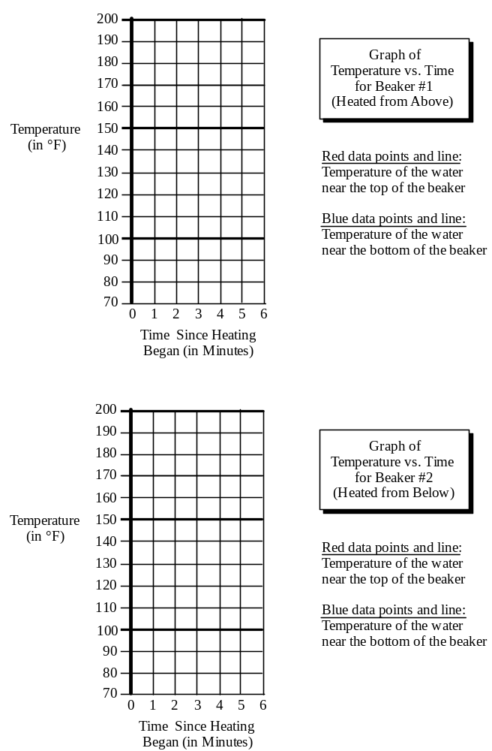
2nd Part of the Activity (Beaker #2):
1. Fill the empty large beaker with 1000 ml of cold tap water.
2. Place the beaker of water on the cool hot plate. DO NOT TURN ON THE HOT PLATE (YET).
3. Complete Steps 2 and 3 as you did for Beaker #1 (see p. A–55).
4. Turn on the hot plate at a low setting.
5. Complete Steps 5 and 6 as you did for Beaker #1 (see p. A–55 to A–56).
6. Turn off the hot plate.
7. Complete Step 8 as you did for Beaker #1 (see p. A–56).

Observation Question
1. Complete the diagrams below, showing the motion of the blue-colored water immediately after heating began.

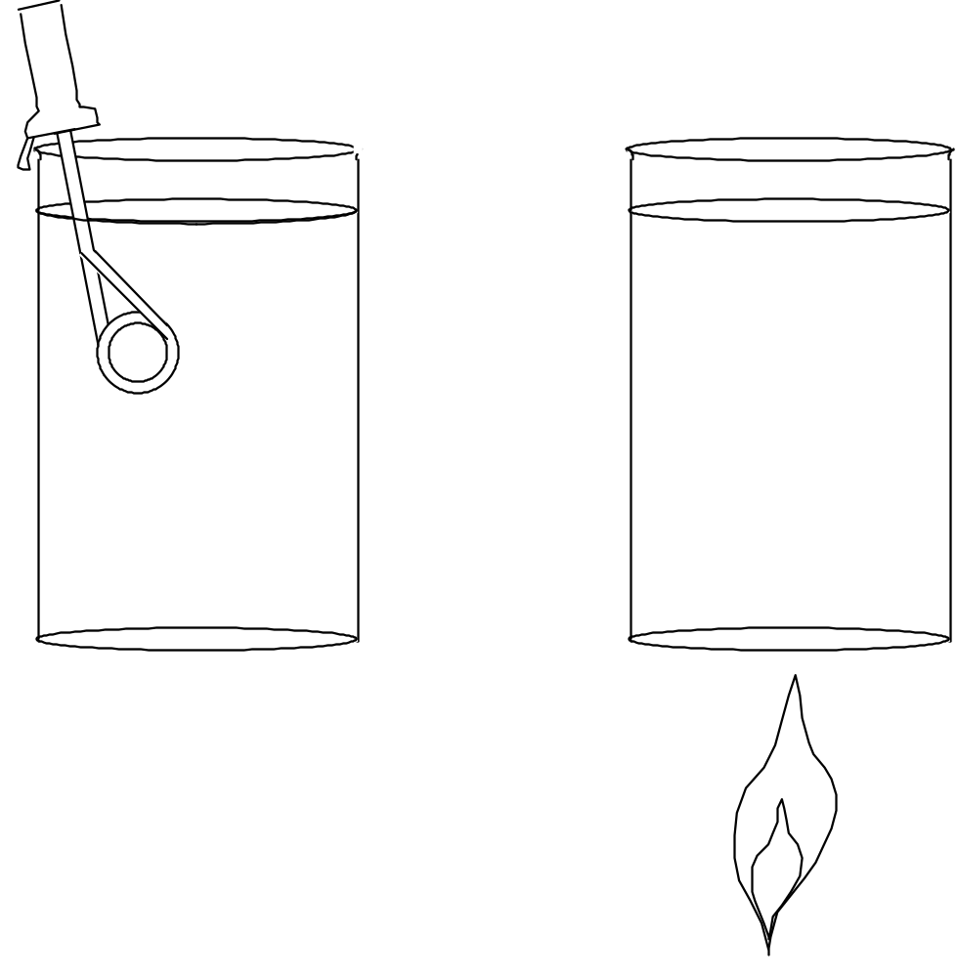
a. Beaker #1 b. Beaker #2

Thought/Interpretation Questions
2. Using the concepts you learned from Activities #2, #3 and/or #4, explain why any motion of the blue-colored water occurred.

3. If little or no motion of the blue-colored water occurred in one of the beakers, use the concepts you learned from Activities #2, #3 and/or #4, to explain why no motion occurred.

Observation Question
4. Describe the motion of the red-colored water in the two beakers. As appropriate, illustrate your explanation by adding to the diagrams on the previous page.

Thought/Interpretation Questions
5. Using the concepts you learned from Activities #1, #2 and/or #3, explain why any motion of the red-colored water occurred in the two beakers.

Putting it All Together  6. Convection in Beaker #1: Did convection occur in this beaker? If so, did it involve all of the water in the beaker or just some of the water in the beaker? Explain, adding to the adjacent diagram as appropriate. | 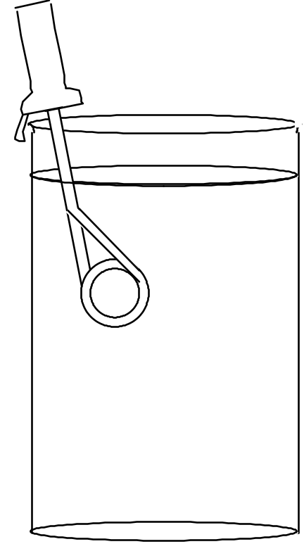
7. Convection in Beaker #2: Did convection occur in this beaker? If so, did it involve all of the water in the beaker or just some of the water in the beaker? Explain. | 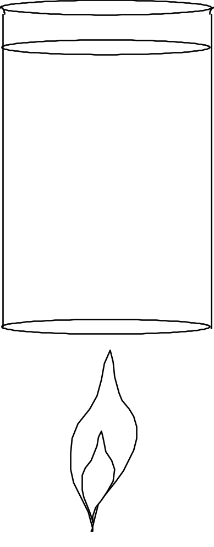
3rd Part of the Activity (Back to Beaker #1):
1. Place the beaker of (now striped) water on the hot plate.
2. Turn on the hot plate at a low setting. Watch what happens.

More Thought Questions:
8. If you want to induce convection in a fluid by adding a heat source, should you place the heat source at the top or the bottom of the fluid? Why?

9. The higher the temperature of a given mass of water, the greater the heat energy content of that water. In which beaker was the heat energy most evenly distributed through the beaker of water?

How did that heat energy get transferred from the water located closest to the heat source to the water located farthest from the heat source?

Lab Activity #6: Cooling a Fluid from Above
Materials: 1 large (1000 ml) pyrex beaker
red and blue food coloring in plastic squeeze bottles (diluted to about half strength)
2 eye droppers
Ice

Activity
1. Fill the beaker full of tap water. Let it stand for awhile to allow the water to settle down.
2. Carefully place a dropper full of red food coloring in the bottom of the beaker, disturbing the water as little as possible. Use the procedure described on p. A–55.
3. Gently place pieces of ice into the water. Drop a few drops of blue food coloring on the ice.
4. Watch what happens.
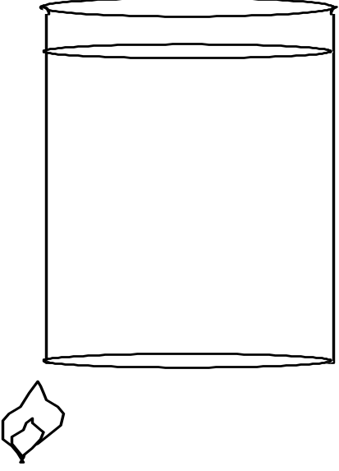
Observation Question
1. Describe what happens. Illustrate your description by adding to the adjacent drawing of a beaker.

2. Did convection occur in the beaker? How do you know?

3. Does convection require a heat source? Why or why not?

5. Putting together everything you have learned from this lab, explain how, why and under what conditions convection occurs in a fluid.

Objectives
When you have completed this lab you should be able to:
1. explain why magma rises through the lithosphere, often making it to the surface and out of a volcano.
2. describe the process of crystallization and how the rate of cooling of a melt affects the sizes of the crystals formed.

Activity #1: Why Does Magma Rise?
Materials: covered test tube of salol (phenyl salicylate) insulated gloves
thermometer test tube rack
hot plate empty test tube
large glass beaker with hot tap water in it crushed ice
Activity
1. Melt most of the salol: Measure the temperature of the hot tap water. If it is below 110°, heat it awhile on the hot plate. Hold the test tube of salol in the hot water, swirling it around gently. Periodically remove it from the hot water and continue to swirl it and see if the salol has melted. Continue this process until the crystals are almost all melted (leave a piece of crystalline salol, about 1/8 inch across, in the melt to act as a seed crystal). This process is analogous to the melting of rock deep within the crust or mantle.
2. Place the test tube of salol in an upright position in the metal test tube rack.
3. Fill the unsealed empty test tube about 1/3 full of tap water. Place a few pieces of crushed ice into the water (if the ice melts, just add a little more ice).
Questions:
1. Draw two diagrams, one showing the seed crystal inside the test tube of melted salol and one showing the crushed ice inside the test tube of water.

Test tube with a few crystals Test tube with a few pieces
of salol in molten salol of crushed ice in water
2. Which has a higher density, crystalline (solid) salol or molten (liquid) salol? How do you know?

3. Which has a higher density, water or ice? How do you know?

4. When rock melts, deep under ground, it typically isn't any hotter than the unmelted rocks around it; it merely has a lower melting temperature than the rocks around it. Yet, the melt (magma) tends to rise, often making it all the way to the surface as a lava flow. Why does magma begin to rise, even though it's no hotter than the unmelted rocks around it?

Activity #2: Melting and Crystallization
Materials: several sealed test tubes of salol (phenyl salicylate)—there should be one per person
plastic beaker of hot tap water (get from front sink)
hot plate
large glass beaker with boiling water in it
thermometer
insulated gloves
1 beaker filled with ice water (get ice from front counter)
10x magnification hand lenses
large example of radiating clumps of crystals (in a box)
large example of a single crystal (in a box)
Make a Prediction: In this activity, you will be melting and then cooling (and therefore crystallizing) molten salol at two different speeds. The possible results are as follows:
a. The salol whose temperature drops faster will form larger crystals.
b. The salol whose temperature drops more slowly will form larger crystals.
c. The rate of cooling will not make any difference; the crystals will be the same size, no matter how quickly the temperature of the salol drops.
Choose the result that you think will occur. Explain the reasoning behind your answer.

Activity
1. Melt the salol: Use the same procedure you used for Activity #1, Step 1.
2. Simulate the formation of a volcanic rock: Take half of the test tubes out of the hot water and place them in the ice water. Swirl each test tube in the ice water for a few seconds and then, for 5 seconds or so, rotate the test tube while holding it sideways, coating the insides of the test tube with the melt. Repeat these two steps until all of the salol had crystallized (a minute or so). This rapid cooling process is analogous to the formation of a volcanic rock; the melted rock (lava) cools and crystallizes quickly because it erupts onto the Earth's surface, which is much cooler than the depths of the Earth. Look at the crystals with a hand lens; note the sizes of the crystals.
3. Simulate the formation of a plutonic rock: Take the remaining half of the test tubes out of the hot water and slowly rotate each tube while holding it sideways, coating the insides of the test tube with the melt. Continue rotating slowly until all of the salol has crystallized (about 5 minutes). This slow cooling process is analogous to the formation of a plutonic rock; the melt cools and crystallizes slowly because it stays deep underground and has a thick insulating layer of rock above it. Look at the crystals with a hand lens; note the sizes of the crystals.

Questions:
1. Which procedure produces larger crystals, a rapid temperature drop or a gradual temperature drop? Why?
Hint: Be sure to base your answer on the sizes of individual crystals; not on clumps of small radiating fibrous crystals (see the large example of similar clumps of crystals). Large individual crystals of salol are diamond shaped if they are free to grow without bumping into other crystals (see the large example of a similar crystal).

2. Draw enlarged sketches of some of the crystals in each test tube.

Crystals that formed when the Crystals that formed when the
salol cooled quickly salol cooled slowly
3. Which should have larger crystals, volcanic rock or plutonic rock? Explain the reasoning behind your answer.

4. What would happen if the melt were chilled so suddenly that the crystals had no time to form? Why?

5. In terms of crystal size, what would happen if the liquid salol cooled slowly for awhile and then was cooled quickly (placed in ice water)? Explain the reasoning behind your answer. If there's time, try it!

6. If magma cools slowly deep underground for awhile and is then expelled quickly onto the surface, will the crystals be big or small? Explain the reasoning behind your answer.

Activity #3: Watching the Crystallization Process
Materials: glass Petri dish full of salol (phenyl salicylate), with glass cover.
hot plate
10x magnification hand lenses
insulated gloves
paper towels
Activity
1. Melt the salol: Set the hot plate on low. CAREFULLY, supporting the bottom of the Petri dish so that it doesn't fall, place the Petri dish on the hot plate with one side hanging 1/4 inch or so over the edge. Let all of the salol melt except for a small amount at the overhanging edge.
2. Remove the salol from the hot plate: Wearing the insulated gloves, CAREFULLY— supporting the bottom of the Petri dish so that it doesn't fall—remove the Petri dish from the hot plate and place it on the lab table. If the cover glass fogs up (usually it does), briefly place the cover glass upside down on the hot plate; then wipe the inside with a paper towel and put it back on the Petri dish. .
2. Watch the salol crystallize again: Using the magnifying hand lens, watch the crystals form and grow.

Questions:
1. Do crystals start growing all over the dish or do they start in a few spots and grow bigger from there? Describe what happened.

2. Try repeating the experiment but place the dish on a bed of ice. This time, do the crystals start growing all over the dish or do they start from a few spots and grow bigger from there?

Objectives
When you have completed this lab you should be able to:
1. describe the fundamental difference between glass and crystalline material.
2. tell the following apart:
a. natural glass
b. rock made of intergrown microscopic crystals
c. rock made of intergrown crystals that are big enough to see
d. rock made of a mixture of microscopic crystals and crystals big enough to see
3. look at an igneous rock and determine whether it (a) crystallized slowly deep underground or (b) came out of a volcano as lava and then crystallized quickly on the Earth's surface.
4. identify six types of igneous rocks and, as appropriate, add adjectives to the names.

Activity #1: Judging the Sizes of Crystals in a Rock and Distinguishing Crystalline Material from Glass
A. Materials: coarse brown (raw) sugar
golden brown sugar
butterscotch candy
Rocks Q, R, V, W
10x magnification hand lenses
B. Activity: Using the magnifying hand lens, closely examine the sugar, the candy and the rocks. Note the presence or absence of crystals. Note the sizes of any crystals present.
C. Questions:
1. Draw lines connecting each substance with the appropriate description.
Substance Description
coarse brown (raw) sugar Made of unordered atoms; contains no crystals
golden brown sugar
butterscotch candy Made of tiny microscopic crystals
Rock Q
_{Rock R} Made of “large” crystals, big enough to
distinguish with the naked eye
Rock V
Rock W Made of a mixture of large and tiny crystals
2. Which of the rocks (Q, R, V and W) are plutonic? Which are volcanic? Explain the reasoning behind your answers.

3. Describe how each rock formed. Include in your description the type of environment in which the rock formed (i.e. deep underground, on the Earth's surface) and how quickly it cooled and solidified.
a. Rock Q

b. Rock R

c. Rock V

d. Rock W

Activity #2: Classification of Igneous Rocks
Introduction: Geologists classify igneous rocks by their texture and composition. The chart below shows the igneous rock classification system that we will use for this class.

Classification of Igneous Rocks (all rock names are in bold face)

Composition | Felsic (High in Silica) | Mafic (Low in Silica)
Overall Color* | Cream, Pink, or Light Gray | Dark Gray to Black
Plutonic  (All grains large enough to distinguish with the naked eye) | Granite | Gabbro
Volcanic  (Most grains microscopic) | Rhyolite | Basalt
Volcanic Glass  (disordered mass of atoms; not crystalline) | Obsidian: very shiny; breaks into smooth curved surfaces with very sharp edges; often dark gray, black or red, despite its felsic composition.
 | Pumice: so full of holes it looks frothy; very low density; may float on water.

Special Textures of Some Volcanic Rocks
These texture names are used as adjectives added to the rock names. For example, you might have a porphyritic basalt.
Porphyritic: a mixture of microscopic crystals and crystals large enough to see.
Vesicular: containing large rounded holes (frozen gas bubbles)**
Materials: 10 igneous rocks labeled A, B, O, Q, R, S, U, V, W, X
one magnifying hand lens per person
12 pieces of 8.5" x 11" scrap paper

Activity: Use the 12 pieces of scrap paper to make a LARGE copy of this classification table, spread out on your lab table. It should look something like the table on the right--a simplified version of the Classification of Igneous Rocks on the previous page (with rock names in bold type). Place all 10 rocks on the appropriate pieces of paper. Have your instructor check your work.

 | Felsic | Mafic
Plutonic | Granite | Gabbro
Volcanic | Rhyolite | Basalt
Volcanic | Obsidian
Volcanic | Pumice

1. Write the name of each rock next to its letter:
A. S.
B. U.
O. V.
Q. W.
R. X.
More Activity: Some of the volcanic rocks have special textures. In other words, some of the volcanic rocks are vesicular and some are porphyritic (some may even be both). Examine all of the volcanic rocks and figure out which are vesicular, which are porphyritic, which are both, and which are neither.
2. List the letters of all the vesicular volcanic rocks:
3. List the letters of all the porphyritic volcanic rocks:

Activity #3: The Source of Volcanic Gas

Materials: One warm bottle of carbonated water (soda water)—on the front lab table
One warm bottle of water that is not carbonated—on the front lab table
Video of the eruption of Kileaua (Volcanoscapes: Pelé's March to the Pacific)
Video segment of the eruption of Mt. St. Helens
Questions to Answer BEFORE Doing the Activity (While the Bottle is Still Sealed)
1. Compare the water in the two bottles. Can you see any difference? Can you determine which bottle contains carbonated water and which bottle contains plain water?

2. What do you predict will happen when the instructor opens the bottle of carbonated water? Why?

Activity (This activity will be performed by the lab instructor):
1. Watch the segment of the video on the eruption of Kileaua on the Big Island of Hawaii. This video shows a beautiful fountain-type of eruption.
2. Spread newspapers over the front counter.
3. Rapidly open the bottle of warm carbonated water.
Questions to Answer AFTER Doing the Activity
3. Describe what happened when the instructor opened the bottle.

4. Where did the gas bubbles come from?

5. Why did the gas bubbles form?

6. Examine a piece of vesicular basalt. The round holes are gas bubbles that formed when the rock was still a molten liquid. Was the gas that formed these bubbles made up of air that got into the lava or was it made up of gas that somehow came out of the lava? Explain.

More Activity (This activity will be performed by the lab instructor):
1. Watch the segment of the video on the eruption of Mt. St. Helens in the State of Washington. This video shows a violent explosive eruption in which lava sprayed up into the air as tiny rapidly-moving droplets that solidified in the air and rained down as gray volcanic ash. This eruption occurred suddenly, immediately after an earthquake shook loose the giant “plug” of rock that had been blocking the volcanic vent and allowed it to instantly slide down the volcano and open the vent.
2. Spread newspapers over the front counter.
3. Take a factory-sealed very warm bottle of carbonated water and shake it vigorously. Then rapidly open the bottle.

More Questions:
7. Describe what happened when the instructor opened the bottle.

8. What do you suppose could cause a volcano to erupt explosively (like Mt. St. Helens) as opposed to quietly fountaining (like Kileaua)? Hint: it has something to do with pressure.

I. Overview of Geosciences 342
A. Topics
1. Geology
a. Earthquakes and plate tectonics
b. The rock cycle
c. The hydrologic cycle
2. Astronomy
a. The moon: phases, eclipses, changes in rise/set times
b. Apparent and actual motion of stars, planets, sun and moon
c. Why does Earth have seasons?
3. Meteorology
a. The greenhouse effect
b. What makes the wind blow?
c. What makes clouds?
B. Themes
1. Models: “A model of something is a simplified imitation of it that we hope can help us understand it better. A model may be a device, a plan, a drawing, an equation, a computer program, or even just a mental image.” (p. 168, Science for All Americans, by the American Association for the Advancement of Science, 1990). In this class, we will be using a lot of physical models. Physical models are made of materials that behave analogously to (but not exactly like) the real earth materials they are modeling. The behavior of a model is always a bit different from that of the real thing (for example, the model is almost always simpler than the real thing).
2. Flow of Energy and Matter: Energy flows through the Earth System, often changing form as it does so; matter is recycled within the Earth system. The recycling of matter is powered by the energy flow.
3. Convection: Convection happens when fluids are hotter on the bottom than they are on the top because a change in temperature causes thermal expansion/ contraction which causes a change in density which causes a change in buoyancy which causes fluid to rise/sink.
4. Apparent Motion: We can understand the apparently complex motions of the sun, moon, stars, wind and ocean currents by taking into account our rotating revolving reference frame (i.e. the solid Earth).
5. Changes of State: Changes of state (melting, crystallization, condensation, evaporation, boiling) happen at special threshold temperatures; those threshold temperatures vary with changes in pressure and composition.
II. The Cause of Ground Shaking During Earthquakes: Elastic Rebound Theory
A. Terminology
1. Strain:

2. Elastic strain:

3. Elastic potential energy:

B. Review of Lab Results
1. Changes in Shape of Foam Rubber (Exaggerated) + Related Transfer of Energy
a. Starting position for foam rubber model
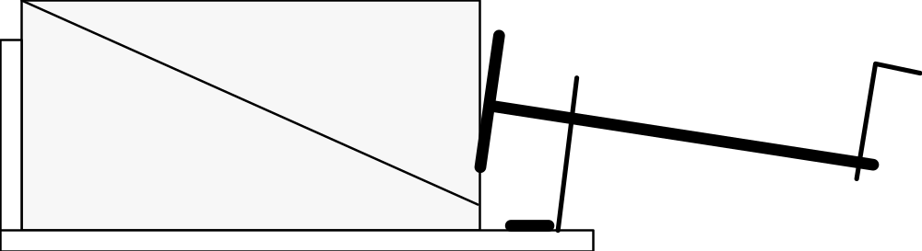
i. What is the state of the foam rubber?

• Any elastic strain?

• Any stored elastic potential energy?

ii. What is the state of the fault?

• What forces are acting on the fault surface?

• Has there been any fault slip?
b. As you turn the crank
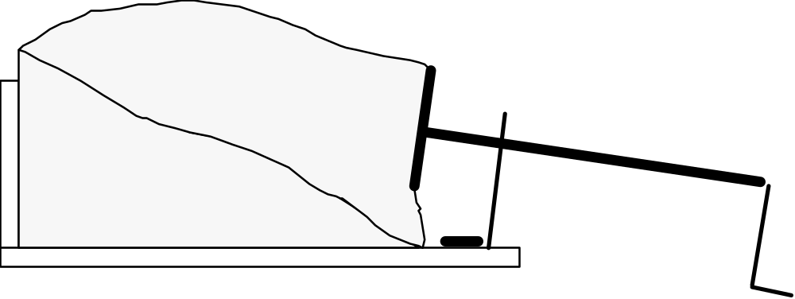
i. What is the state of the foam rubber?

• Any elastic strain?

• Any stored elastic potential energy?

ii. What is the state of the fault?

• What forces are acting on the fault surface?

Elastic Force:

Friction:

• Has there been any fault slip?
c. Just before an earthquake
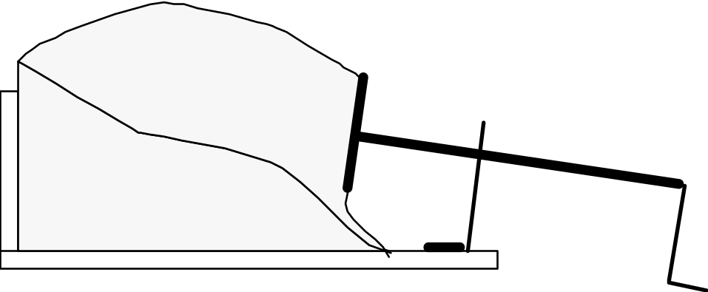
i. What is the state of the foam rubber?

ii. What is the state of the fault?

d. An earthquake happens
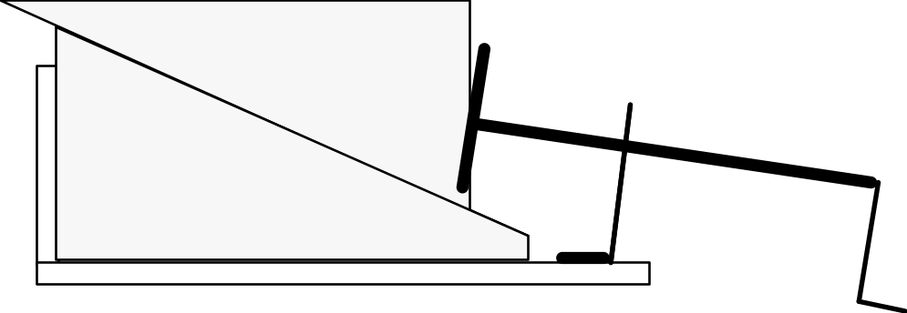

i. What happens to the foam rubber during the earthquake?

ii. What happens to the fault during the earthquake?

iii. Where did all the energy go?
3. Application of the model to the real world
(See the diagram on page A–4 of the course packet):

4. What causes the shaking?

5. Why do waves spread out from the epicenter of the earthquake?

IV. World-Wide Distribution of Earthquakes (See Figure 8.12 on page 229 and compare it to Figures 7.14 on page 200 and 7.10 on pages 196-197 of the textbook)
A. Describe any patterns to the world-wide distribution of earthquakes.

B. Why does this pattern exist?

I. Convection of a Fluid
A. Concept Map of Convection
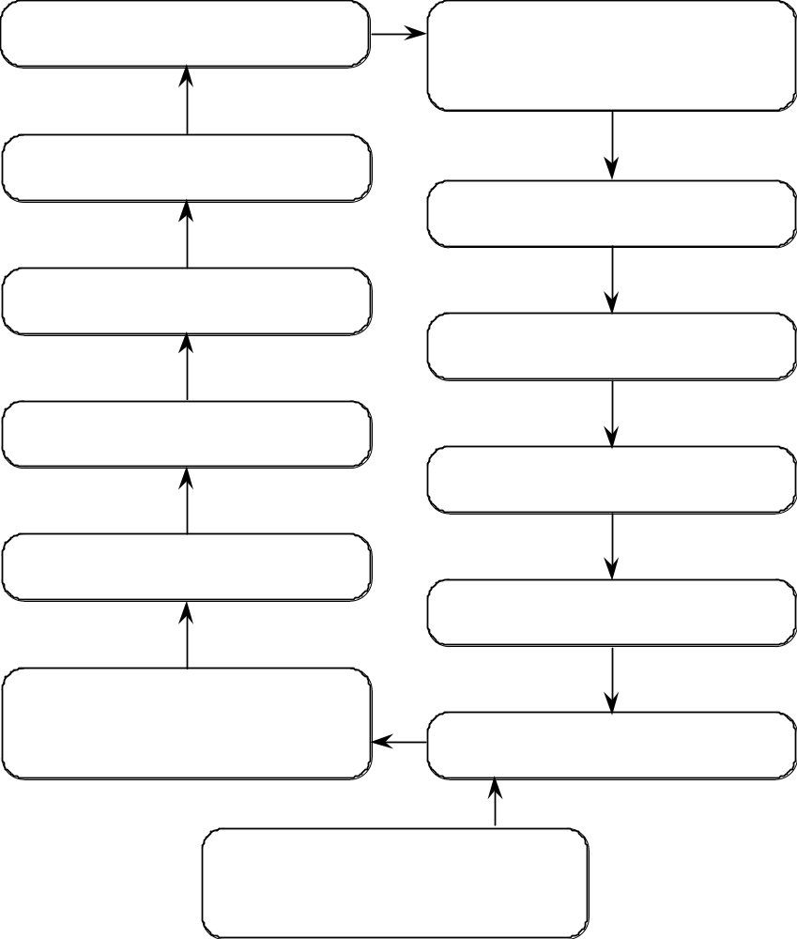

B. Conditions Needed for Convection 1.
2.
II. Convection in Earth's Mantle
A. Environmental Conditions in Earth's Interior
1. As you go deeper into Earth's interior, the temperature continually
2. Will this type of temperature distribution encourage convection?
3. What are the sources of heat in Earth's interior?
a.

b.

B. The Earth's mantle is made of solid rock. Convection happens in fluids. How can solid rock convect?
1.

2.

III. The Relationship Between Mantle Convection and Plate Tectonics
A. Illustration of model (Figure 7.30 B on p. 213 of the textbook)

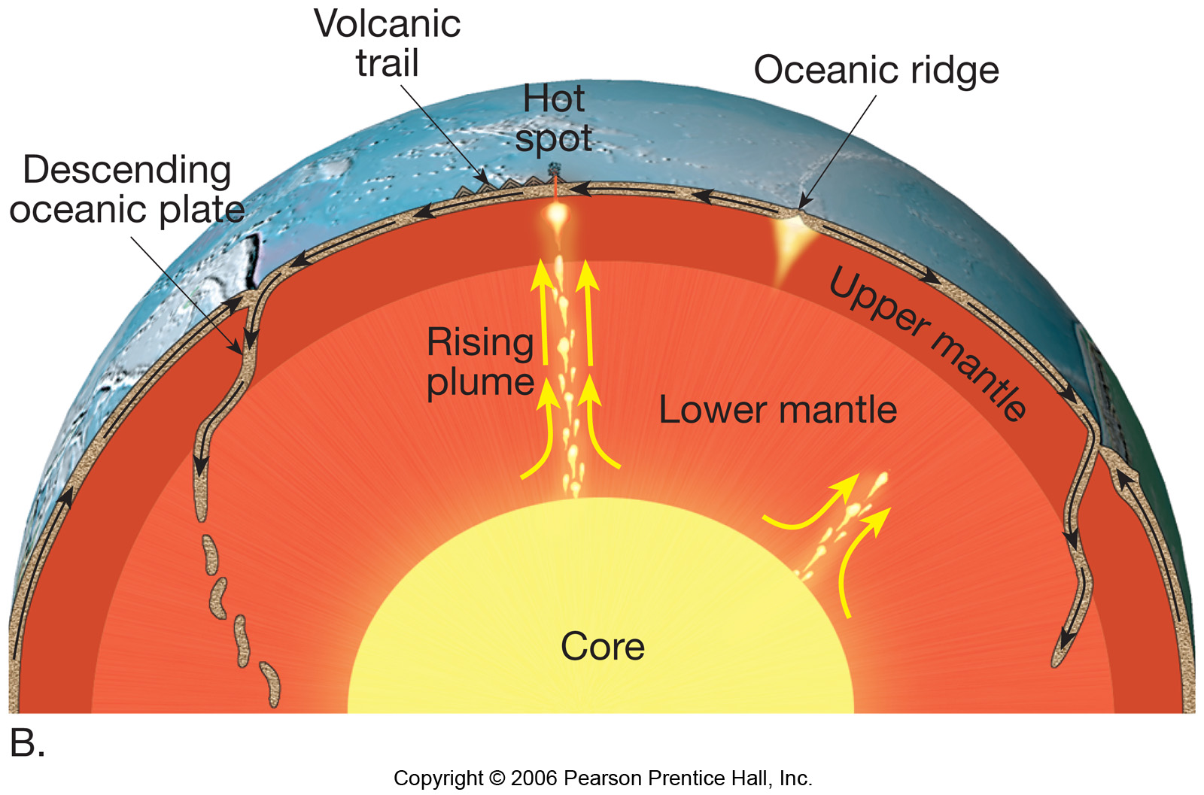

B. Description of model
1. Upwelling convection currents
a. Location:
b. Description:
2. Downwelling convection currents
a. Location:
b. Description:

IV. What makes the plates move?
- The slab-pull hypothesis: brief summary
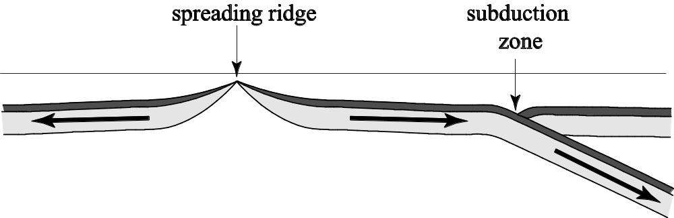
B. How does the slab-pull hypothesis work?
1. Densities:
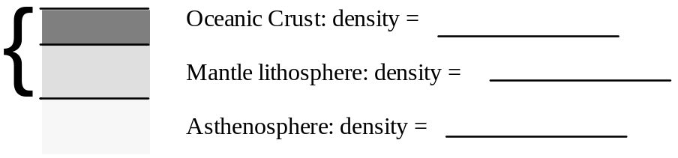
2. Changes in oceanic plates with time (and with distance from the spreading ridge)
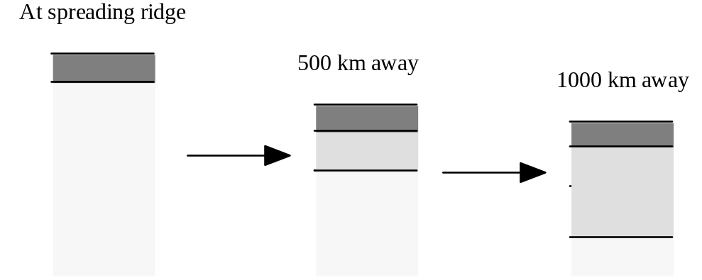
3. What happens to the overall density of an oceanic plate as it moves away from the spreading ridge?

4. Why do oceanic plates subduct?

I. The Question for Today: Why are there volcanoes in some places but not others?
A. What is a volcano?

B. Where does magma come from? How does it get to the volcano?

C. Where are volcanoes found?
1.
2.
3.
D. What is happening at depth underneath every volcano?

II. How to Melt a Rock
A. A rock melts whenever
the temperature of the rock is its melting temperature.
B. Ways to Melt a Rock
1. You can melt a rock by
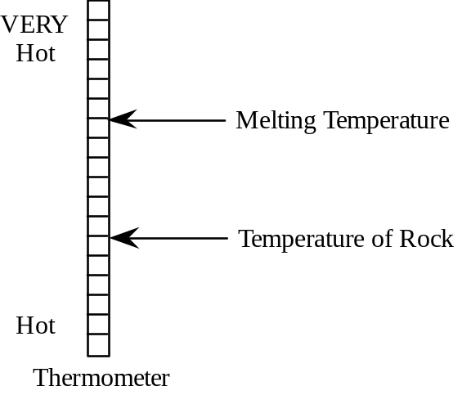
2. You can melt a rock by

C. Two Ways to Lower the Melting Temperature of a Rock
1. You can lower the melting temperature of a rock by
Explain.

2. You can lower the melting temperature of a rock by
Explain.
a. Rocks must in order to melt.
b. The higher the pressure on a rock, the it is for the rock to expand.

III. Causes of MANTLE Melting in Various Tectonic Settings (most magma comes from the mantle)
A. Hot Spots (Often in Middle of Plate)—See Fig. 7.21 on p. 207 and 7.30B on p. 213.
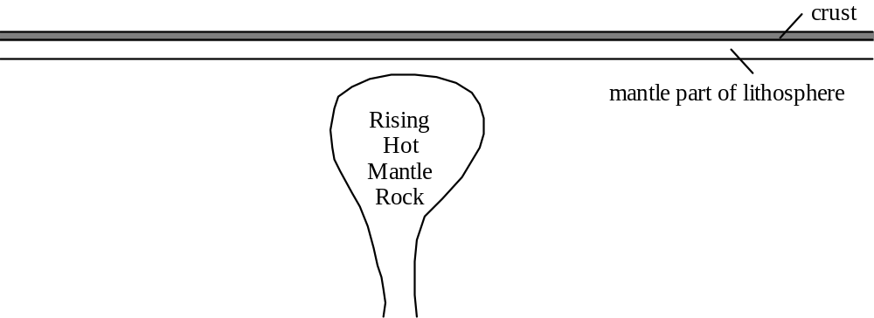

B. Mid-Ocean Spreading Ridges (Divergent Plate Boundaries)—See Fig. 7.11 on p. 198.

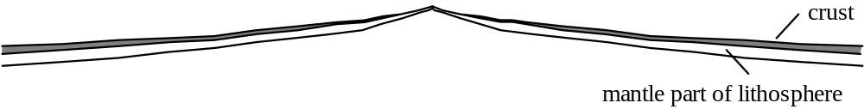

C. Subduction Zones (Convergent Plate Boundaries)—See Fig's 7.15A and 7.15B on p. 201.

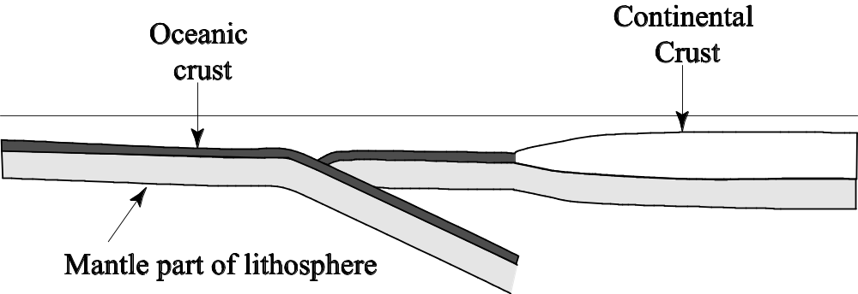

IV. Causes of Melting of Continental Crust

IV. Puzzler: Why is most of Earth’s interior solid rock, even though all rocks below a depth of 200 km are hotter than 1200°C (the temperature of the hottest lavas)?

Some Comments on the Real Exam
• This exam covers all material included in Part A of your course packet, except the Planetarium lab.

• The essay questions will usually involve identification of rock samples, viewing of videotapes, watching demonstrations, or doing experiments.

Practice Multiple Choice Questions
1. According to the elastic rebound theory, earthquakes occur when rocks on either side of a fault…
a. bounce back and forth against the fault surface as it repeatedly opens and closes.
b. “snap back” to their original positions, undoing any recent fault motion.
c. “snap back” to their original shape, undoing any bending that took place before the fault broke.
d. rebound, regaining their original size after being squeezed by the pre-earthquake stress buildup.
e. Both c and d.
2. The three geologic environments that generate large amounts of magma are…
a. convergent plate boundaries, transform plate boundaries, and hot spots.
b. transform plate boundaries, hot spots, and divergent plate boundaries.
c. transform plate boundaries, divergent plate boundaries, and convergent plate boundaries.
d. divergent plate boundaries, convergent plate boundaries, and hot spots.
e. divergent plate boundaries, spreading ridges, and transform plate boundaries.
3. Why does magma rise toward the earth's surface?
a. The magma is denser than the surrounding rock.
b. Rock expands when it melts.
c. Magma is richer in silica than solid rock.
d. Liquids are less buoyant than solids.
e. Heat rises.
4. The driving force for plate motion is thought to be…
a. the gravitational pull of the sun, moon and planets.
b. deep ocean water currents.
c. swirling movements of the molten iron particles in the outer core.
d. the transfer of heat from deep in Earth’s interior to the surface.
e. sunspot activity.

5. Why is the Pacific plate moving toward the northwest?
a. The northwestern margin of the plate is sinking into the asthenosphere, dragging the rest of the plate with it.
b. Convection currents in the asthenosphere underneath the plate are moving toward the northwest.
c. Upwelling mantle at the East Pacific Rise (the sea-floor spreading ridge that forms the eastern margin of the Pacific plate) pushes the plate up and away from the East Pacific Rise.
d. The hot-spot under Hawaii is moving toward the northwest.
e. The North American plate is sliding past the Pacific plate toward the southeast.
6. The earth's lithosphere is comprised of…
a. the crust and the mantle.
b. the crust and the asthenosphere.
c. the crust and the uppermost part of the mantle.
d. the upper and middle portions of the mantle.
e. the ductile part of the crust and the brittle part of the mantle.
7. You can melt a hot rock by the temperature, the pressure and/or the water content.
a. increasing; increasing; increasing.
b. increasing; decreasing; increasing.
c. increasing; increasing; decreasing.
d. increasing; decreasing; decreasing.
e. decreasing; decreasing; decreasing.
8. A dark-colored igneous rock made of crystals large enough to see…
a. cooled slowly from a mafic melt deep underground.
b. cooled quickly from a mafic melt at the surface.
c. cooled slowly from a mafic melt at the surface.
d. cooled slowly from a felsic melt deep underground.
e. cooled quickly from a felsic melt deep underground.

Questions About Hands-On Materials
1. (one egg, one glass half full of water, 1/2 cup salt—do this at home)
Activity: a. Place the egg in the water. Note that it sinks.
b. Then take the egg out of the water.
c. Add the salt to the water and stir well.
d. Place the egg in the water again.
Question: Why does the egg float in the salty water but sink in the fresh water?

2. ( Plastic container with purple, green, pink and clear liquids in it)
a. Which is denser, the purple liquid or the green liquid?
b. Which is denser, the pink liquid or the clear liquid?
c. Explain the reasoning behind your answers to questions a and b.

3. (large model of the San Andreas fault)
This apparatus was designed to model the behavior of the San Andreas fault. Here is how it works: Turn the knob counterclockwise as far as it will go. Insert a toothpick in the holder at the front end of the model. Place “buildings” at various places on the model. Gradually turn the knob clockwise until an earthquake occurs.
Questions:
a. Explain the ways in which this model acts like the real crust near a fault.

b. Explain the ways in which this model behaves differently from the real crust near an earthquake fault.

4. (bottle of motor oil and corn syrup)
Let the bottle rest, upside down, for awhile. Then turn the bottle over and watch as the motor oil rises up through the corn syrup. Notice that the last of the motor oil gradually gathers together and forms drop-shaped masses in the center of the bottle. Then, slowly, they let go and rise, behaving very much like magma bodies rising through the crust.
a. Draw a diagram of what one of the rising oil drops would look like if it were frozen into place. What kinds of rock would be likely to form a large mass, deep within the Earth, with this shape? Why?

b. Why do magma bodies rise up through the crust?

5. (igneous rock that is made up of white, gray, black and pink speckles)
a. Identify this rock.
b. Did this rock solidify on the earth's surface or underground or both (if both; elaborate)?

c. Is this igneous rock felsic or mafic?
d. Explain the reasoning behind your answer to question c.

6. (large black igneous rock)
a. Identify this rock.
b. Is this rock a glass or is it made of microscopic crystals?

c. Explain the reasoning behind your answer to question b.

7. (two black igneous rocks)
a. Identify rock a.
b. Identify rock b.
c. Which rock crystallized deep underground?
d. Explain the reasoning behind your answer to question c.

8. (two cream-colored igneous rocks)
a. Identify rock a.
b. Identify rock b.
c. Describe how rock a formed.

d. Describe how rock b formed.

e. Which of the following statements are correct? (circle all correct answers)
Both rocks are felsic.
Both rocks are low in silica.
Rock a crystallized slowly but rock b crystallized quickly.

Essay Questions
1. An earth science textbook (Earth Science and the Environment, by Thompson and Turk) states “An earthquake is a sudden motion or trembling of the Earth. The motion is caused by the release of slowly accumulated energy in rocks. What is the source of this energy, how does it accumulate in rocks, and why does it suddenly cause the Earth to shake?” Answer the three questions in the last sentence.

2. Figure 8.24 on p. 238 shows the predictions, made by seismologists before the 1989 “World Series” earthquake, of the probability of an earthquake between 1988 and 2018 along various segments of the San Andreas fault. How did seismologists make these predictions? What were their underlying assumptions?

3. The “plates” of plate tectonics are pieces of the thin brittle outer “skin” of the Earth. What parts of the crust, mantle and core are included in this “skin?”

4. Why must a planet with divergent plate boundaries also have convergent plate boundaries?

5. How does the temperature of a substance affect its volume, density and buoyancy?

6. What is the energy source and driving mechanism for the movement of plates? Describe how this process works.

7. Two identical containers of water are heated, one from above and one from below. Which will heat more evenly (i.e. in which container will the temperature rise most uniformly)? Why?

8. Most magma is generated by melting of the mantle or the lower crust. But most of this magma doesn't stay at depth where it formed; it rises toward the Earth's surface. Why?

9. Hot asthenosphere rises to fill in the crack in the lithosphere caused by sea-floor spreading. As it does so, it partially melts. Why does it melt?

10. Which forms the largest crystals, rapid cooling of a melt or slow cooling of a melt? Why?

11. Why is magma generated at subduction zones?

Multiple Choice Questions
1. e 2. d 3. b 4. d 5. a 6. c 7. b 8.a
Questions About Hands-On Materials
1. (one egg, one glass half full of water, 1/2 cup salt—do this at home)
Activity: a. Place the egg in the water. Note that it sinks.
b. Then take the egg out of the water.
c. Add the salt to the water and stir well.
d. Place the egg in the water again.
Question: Why does the egg float in the salty water but sink in the fresh water?

The egg sinks in the fresh water because the egg is denser than fresh water.

The egg floats in the salty water because the egg is less dense than the salty water. The egg has not changed density; the water has. The salty water is denser than both the fresh water and the egg because salt ions have squeezed themselves into the spaces between the water molecules, packing more matter into the same amount of space.
2. (Plastic container with purple, green, pink and clear liquids in it)
a. Which is denser, the purple liquid or the green liquid? green
b. Which is denser, the pink liquid or the clear liquid? pink
c. Explain the reasoning behind your answers to questions a and b.

Denser liquids are less buoyant, so they sink to the bottom. Both the green liquid and the pink liquid sink to the bottom. The purple and clear liquids rise to the top, so the purple liquid is less dense and more buoyant than the green liquid. Likewise, the clear liquid is less dense and more buoyant than the pink liquid. Note that we cannot determine, from this experiment, the relative densities of the liquids that are next to each other. For example, the pink liquid may be less dense than the purple liquid even though the pink liquid always sinks to the bottom and the purple liquid always rises to the top. This is because the purple liquid is not in contact with the pink liquid.
3. (large model of the San Andreas fault)
This apparatus was designed to model the behavior of the San Andreas fault. Here is how it works: Turn the knob counterclockwise as far as it will go. Insert a toothpick in the holder at the front end of the model. Place “buildings” at various places on the model. Gradually turn the knob clockwise until an earthquake occurs.
Questions:
a. Explain the ways in which this model acts like the real crust near a fault.
Elastic strain builds up gradually. As it does so, there is essentially no movement on the fault. After a certain amount of elastic strain has built up, the fault suddenly slips, releasing a great deal of built-up elastic strain.
b. Explain the ways in which this model behaves differently from the real crust near an earthquake fault.
In this model, the elastic strain is stored in the two springs and in the toothpick; the “crust” on either side of the fault does not change shape as the elastic strain builds up; it also doesn't change shape as the elastic strain is released (the springs and the toothpick do). In the real crust, the elastic strain is stored in the crust on either side of the fault so the real crust gradually becomes bent, squeezed, stretched or otherwise warped as the elastic strain builds up. When the elastic strain is suddenly released, the crust on either side of the fault regains (at least some of) its original shape.
In the model, the fault suddenly slips when the toothpick cannot bend any more and suddenly breaks. In other words, fault slip occurs when the elastic force in the springs, trying to return them to their original shape, exceeds the strength of the toothpick and the toothpick (which is the only thing holding the two sides of the fault together) breaks.
In the real crust, it is friction that must be overcome, not the strength of the rocks. You do not have to break apart the rocks along the fault--they are already broken.
There is one exception, however. The real crust actually does eventually break when elastic strain builds up in a region where there isn't any fault yet: the rocks keep bending until the elastic force (trying to return the rocks to their original shape) exceeds the strength of the rock and the rock breaks, forming a fault. Once that fault has formed, it will take less build-up of elastic strain to get the fault to slip than it did to form the fault in the first place.
4. (bottle of motor oil and corn syrup)
Let the bottle rest, upside down, for awhile. Then turn the bottle over and watch as the motor oil rises up through the corn syrup. Notice that the last of the motor oil gradually gathers together and forms drop-shaped masses in the center of the bottle. Then, slowly, these drop-shaped masses let go and rise, behaving very much like magma bodies rising through the crust.
a. Draw a diagram of what one of the rising oil drops would look like if it were frozen into place. What kinds of rock would be likely to form a large mass, deep within the Earth, with this shape? Why?
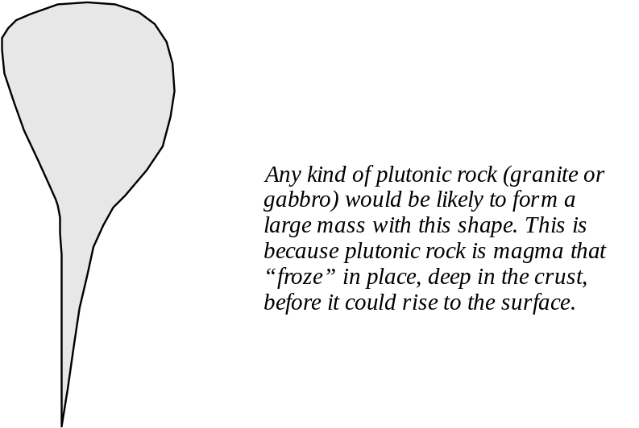
b. Why do magma bodies rise up through the crust?
When rock melts, it expands, taking up more volume in the liquid state than it did in the solid state. Since the mass of the rock doesn't change, its density must then decrease. It is therefore more buoyant than the solid rock around it so it rises.

5. (igneous rock that is made up of white, gray, black and pink speckles)
a. Identify this rock. granite
b. Did this rock solidify on the earth's surface or underground or both (if both; elaborate)?
This rock solidified underground. We know this because the crystals that make up
the rock are large enough to distinguish with the naked eye.
c. Is this igneous rock felsic or mafic? felsic
d. Explain the reasoning behind your answer to question c.
The overall color of this rock is a light-pink to beige (there are some black specks in the rock but most of the rock is light colored). Felsic rocks tend to be light-colored.

6. (large black igneous rock)
a. Identify this rock. basalt
b. Is this rock a glass or is it made of microscopic crystals?
microscopic crystals
c. Explain the reasoning behind your answer to question b.
Glass is very shiny and has a smooth texture. This rock is dull and a bit grainy.

7. (two black igneous rocks)
a. Identify rock a. basalt
b. Identify rock b. gabbro
c. Which rock crystallized deep underground? rock b did
d. Explain the reasoning behind your answer to question c.
Rock b has a larger grain (crystal) size. Large crystals can only grow when magma cools slowly, giving the atoms in the melt (where they can move freely) plenty of time to move to a growing crystal and attach themselves to it. When magma (or lava) cools quickly, the atoms don't have time to migrate to the first-formed crystals; instead, they rapidly join together with atoms that are already nearby, forming lots of tiny crystals.

8. (two cream-colored igneous rocks)
a. Identify rock a. granite
b. Identify rock b. porphyritic rhyolite
c. Describe how rock a formed.
Felsic magma cooled slowly underground, forming a mass of large intergrown crystals.
d. Describe how rock b formed.
Felsic magma cooled slowly underground for awhile, forming a few large crystals. Then, suddenly, the magma was expelled out of a volcano and the remaining melt cooled rapidly, forming a mass of microscopic crystals surrounding the already-formed large crystals.

e. Which of the following statements are correct? (circle all correct answers)
Both rocks are felsic.
Both rocks are low in silica.
Rock a crystallized slowly but rock b crystallized quickly.

Essay Questions (There are always many possible good answers to essay questions. We provide here some key points that we would be looking for in good answers)
1. An earth science textbook (Earth Science and the Environment, by Thompson and Turk) states “An earthquake is a sudden motion or trembling of the Earth. The motion is caused by the release of slowly accumulated energy in rocks. What is the source of this energy, how does it accumulate in rocks, and why does it suddenly cause the Earth to shake?” Answer the three questions in the last sentence.

The source of this energy is the kinetic energy of motion of the plates (which comes from Earth's internal heat energy which drives convection).

This energy accumulates in the rocks near the fault as elastic potential energy as the rocks build up elastic strain, bending, squeezing and/or stretching.

When the fault slips, the elastic strain is suddenly relieved, releasing the elastic potential energy as vibrations (kinetic energy)--the rock vibrates before settling to its original shape.

The vibrations are what we feel when the ground shakes.

We feel these vibrations even when we are fairly far away from the fault because the vibrations at the epicenter of the earthquake produce waves of vibrational motion that travel out in all directions.

Diagrams would be appropriate for this question .

2. Figure 8.24 on p. 238 shows the predictions, made by seismologists before the 1989 “World Series” earthquake, of the probability of an earthquake between 1988 and 2018 along various segments of the San Andreas fault. How did seismologists make these predictions? What were their underlying assumptions?
Basis of these predictions: data on the past behavior of the various segments of the fault: i.e. when did earthquakes occur in the past and how big were they? Some of these data come from historical records; some of them come from paleoseismological studies (such as the one conducted by Kerry Sieh).
Underlying assumptions: the amount of elastic strain that builds up and between earthquakes and the amount that is released during each earthquake is reasonably consistent.

3. The “plates” of plate tectonics are pieces of the thin brittle outer “skin” of the Earth. What parts of the crust, mantle and core are included in this “skin?”

All of the crust and the uppermost part of the mantle. The uppermost part of the mantle is cool, rigid and stuck firmly to the crust above; it is not stuck firmly to the asthenosphere below.

Note: diagrams would be appropriate for this answer.

4. Why must a planet with divergent plate boundaries also have convergent plate boundaries?

New lithosphere is added wherever there is a divergent plate boundary. If we kept creating new lithosphere without destroying any, Earth would blow up like a balloon--and its overall density would have to continually decrease. We have no evidence Earth is expanding or decreasing in density so there must be just the right amount of lithosphere being destroyed at convergent plate boundaries to balance out the amount of lithosphere being created at divergent plate boundaries.

Note: diagrams would be appropriate for this answer.

5. How does the temperature of a substance affect its volume, density and buoyancy?

As the temperature of a substance increases its volume increases. Density = mass / volume. Thus, if the volume increases but the mass does not, the density must decrease. Whenever the density of a substance decreases, its buoyancy increases. Caution: when a phase change occurs (such as liquid to solid, gas to liquid), this rule may not hold true.

Note: diagrams would be appropriate for this answer.

6. What is the energy source and driving mechanism for the movement of plates? Describe how this process works.

The energy source for the movement of plates is ultimately Earth's internal energy. Earth is hotter in the center than it is on the outside. Heat always flows from hot places to cold places, so heat is constantly flowing from the center of Earth to the outside. Because the mantle (which makes up most of Earth's interior) is hotter on the bottom than it is on the top and because the mantle is capable of flowing (slowly), convection occurs in the mantle. This convection produces vertical and horizontal currents within the mantle. These currents drive plate motion but the exact way in which they do so is not understood at this time.

Note: diagrams would be appropriate for this answer.

7. Two identical containers of water are heated, one from above and one from below. Which will heat more evenly (i.e. in which container will the temperature rise most uniformly)? Why?
The container of water that is heated from below will heat very evenly. The container of water heated from above will heat very unevenly. This is because convection will occur in the container heated from below but not in the container heated from above.
The container heated from below: water near the bottom of the container will absorb heat from the heat source by conduction or radiation, increase its temperature, expand, decrease it density, increase its buoyancy and rise. As it does so, cooler denser less buoyant water sinks down to take its place; this water becomes heated and also rises. This process sets up currents that “stir” the water and distribute the heat evenly.
The container heated from above: water near the top of the container will absorb heat from the heat source by conduction or radiation, increase its temperature, expand, decrease its density, and increase its buoyancy. It will, therefore, “float” on the water below and not be able to sink down and mix with it. Thus it will stay near the heat source and its temperature will keep increasing. VERY gradually, the heat stored in the water near the top of the container will transfer, by conduction, to the water near the bottom of the container. This process is very slow because water does not conduct heat very well (this process would happen rapidly in a piece of iron or steel).
Note: diagrams would be appropriate for this answer.

8. Most magma is generated by melting of the mantle or the lower crust. But most of this magma doesn't stay at depth where it formed; it rises toward the Earth's surface. Why?
When rock melts, it expands, taking up more volume in the liquid state than it did in the solid state. Since the mass of the rock doesn't change, its density must then decrease. It is therefore more buoyant than the solid rock around it so it rises.

9. Hot asthenosphere rises to fill in the crack in the lithosphere caused by sea-floor spreading. As it does so, it partially melts. Why does it melt?
The asthenosphere partially melts in this case because it is already quite hot and because it is rising. As it rises, the pressure (from the overlying rock) decreases, making it easier for the rock to expand and, therefore, lowering its melting temperature. Thus the melting temperature can lower to a temperature below the temperature of the rock. Whenever a substance is at a temperature above its melting temperature, it melts.
Note: diagrams would be appropriate for this answer.

10. Which forms the largest crystals, rapid cooling of a melt or slow cooling of a melt? Why?

Large crystals can only grow when magma cools slowly, giving the atoms in the melt (where they can move freely) plenty of time to move to a growing crystal and attach themselves to it. When magma (or lava) cools quickly, the atoms don't have time to migrate to the first-formed crystals; instead, they rapidly join together with atoms that are already nearby, forming lots of tiny crystals.

11. Why is magma generated at subduction zones?

Sea water is constantly flowing through the oceanic crust at the bottom of the ocean. This water reacts chemically with the oceanic crust, incorporating itself into some of the crystals that form the rocks of the oceanic crust. As the oceanic lithosphere subducts, it is subjected to higher and higher pressures. The crystals that contain water become unstable under these new conditions and they recrystallize, releasing their water. This water is, of course, less dense than the rocks around it so it rises up through the mantle rock that is above the subducting oceanic lithosphere. This water then incorporates itself into crystals in that already hot mantle rock. The addition of water to the hot mantle rock lowers its melting temperature. Eventually, the melting temperature of the rock becomes less than the temperature of the rock and the rock melts (partially). The magma produced by this melting is less dense than the rocks around it so it rises. As it does so, it eventually reaches the crust. The magma transfers some of its heat to the crust around it, raising the temperature of the crust and melting it to form more magma (of a slightly different type). All of this magma continues rising through the crust, eventually cooling to form igneous rocks either underground or at the surface.

Note: diagrams would be essential for this answer.

Sources of Information "Ice," Microsoft® Encarta® Online Encyclopedia 2000 (http://encarta.msn.com ©) Senese, Fred, 2000, Department of Chemistry, Frostburg State University, Maryland (http://antoine.fsu.umd.edu/ chem/senese/101/index.shtml) Libbrecht, Kenneth, 1999, Professor of Physics, California Institute of Technology (http://www.cco.caltech.edu/ ~atomic/snowcrystals/ice/ice.htm) Serway, R.A. and Faughn, J.S., 1992, College Physics (3rd edition): Saunders College Publishing, p. 318–319.
We'll find out why later this semester.
In Figure 7.12 and most other figures in the textbook, asthenosphere is shown in deep orange, mantle lithosphere is shown in textured tan; oceanic crust is shown in textured brown and continental crust is shown in off-white. It is helpful to remember this color scheme as you study the plate tectonics diagrams.
We'll learn more about ultramafic rock later this semester.
Remember from lab that any substance expands when its temperature increases and contracts when its temperature decreases.
They actually make high pressure ovens that create conditions similar to those within the mantle.
Seismologists prefer the term “hypocenter” over “focus.” The two terms mean the same thing.
The word “theory” is used differently by scientists than by most other people. In science, a theory is an explanation that explains ALL observations and data. There is no evidence against it. It is as close to the “truth” as you will get in science because you can never prove anything 100% right; you can only prove things wrong.
* Hint: you don't need to do any math to correctly answer this question.
A “volatile” is any substance that readily changes to a gas at the temperatures and pressures typical of Earth’s surface (H₂O and CO₂ are good examples)—definition modified from the one in the textbook on p. 250.
* Activities 3 and 4 were adapted from the “Hot Water, Cold Water” activity in the Full Option Science System (FOSS) Water Module for Grades 3-4. The FOSS curriculum materials were developed under the guidance of Dr. Lawrence F. Lowerey by the Lawrence Hall of Science at UC Berkeley; they are distributed by Encyclopaedia Educational Corporation. The FOSS Water Module is in our library.
**If this set-up has not been completed for you, follow the procedure below: 1. Mix a small amount of water and a few drops of green food coloring in a beaker 2. Pour the green water into the clear glass bottle until it is almost completely full. 3. Push the end of the eye dropper into the hole on the large end of the rubber stopper. 4. Place the rubber stopper on the glass bottle; press down to seal tightly. Some green water should rise up into the eye dropper. 5. If there is any excess green water in the large beaker, discard it.
* Almost all igneous rocks have some mafic (black) minerals in them. Thus many “felsic” rocks have a speckled appearance. That's why we use “overall” rock color (the color of the rock when you see it from a distance) to name the rock. The whole rock is not considered mafic unless it is all dark gray to black (or black and green if it contains the mineral olivine).
** Note that ALL pumice is vesicular; thus we don't ever say “vesicular pumice” because that would be redundant.
In making this prediction, seismologists did not consider the possibility of major ruptures on subsidiary faults such as the one that ruptured in January 1994, causing the Northridge earthquake.
In making this prediction, seismologists did not consider the possibility of major ruptures on subsidiary faults such as the one that ruptured in January 1994, causing the Northridge earthquake.

